|  |
| --- |
| IICT Construction Site  Management System |

|  |
| --- |
| Database Requirement Specification  for |

|  |  |
| --- | --- |
|  |  |

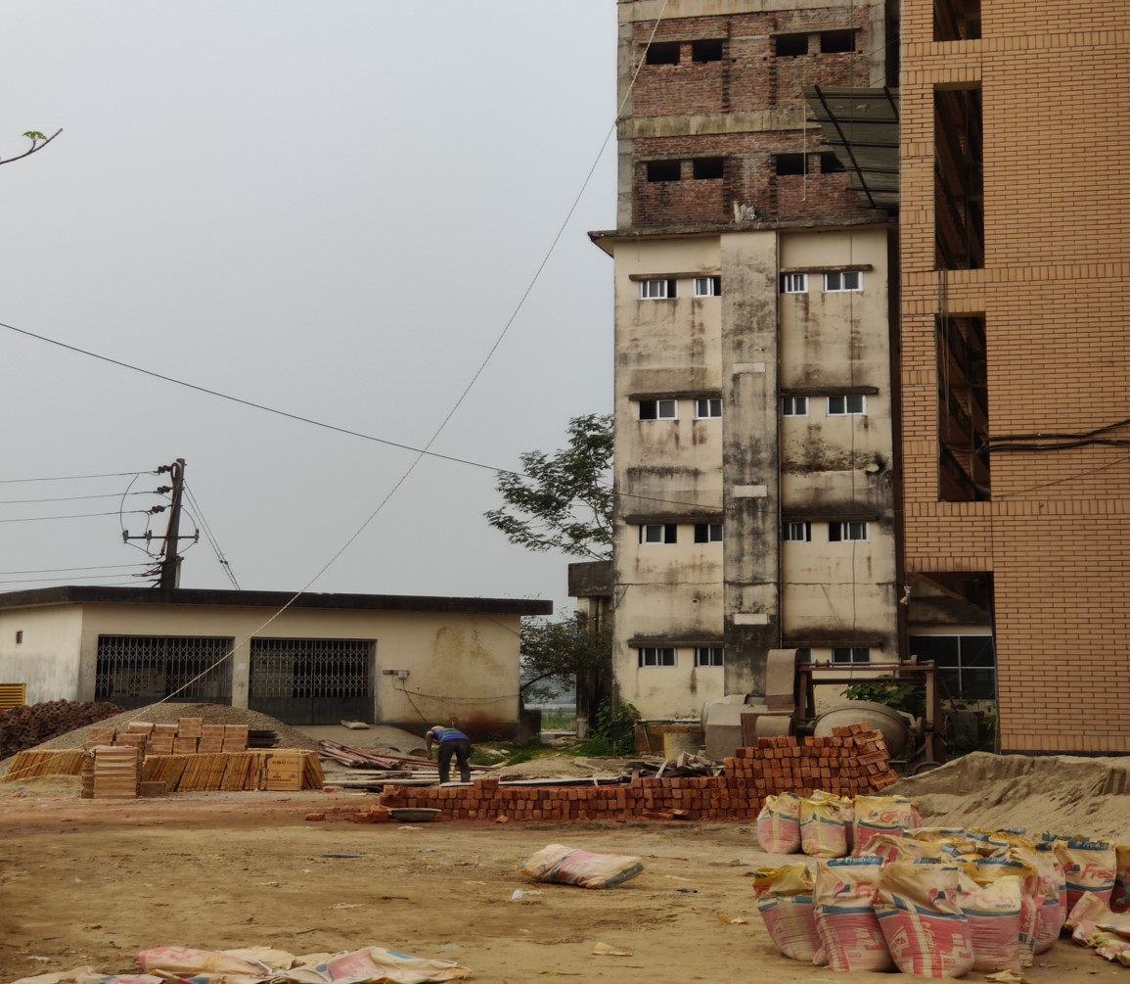

Course Name: Database Management System Lab

Course Code: SWE 328

Project Supervisor:

Dr. Ahsan Habib

Assistant Professor, IICT, SUST

Submitted By:

Team The TechNerds

Team Members:

1. Md Sadman Hafiz (Reg:2018831057)
2. Sanjana Afrin (Reg:2019831054)
3. Ashrafur Rahman Chowdhury (Reg:2019831070)
4. Shaikh Ifaz Aiman (Reg:2019831031)

Date Of Supervision:

15th March 2023

|  |
| --- |
| **LETTER OF**  **TRANSMITTAL** |

15th March,2023

Dr. Ahsan Habib

Assistant Professor,

IICT, Shahjalal University of Science and Technology, Sylhet

Dear Sir,

We have prepared the attached report on the Software Requirements Specifications of “IICT Construction Site Management System” application for your approval. This report describes the project requirements we've gathered so far.

The major objective of this report is to provide a synopsis of our results from our Project field work. This report contains the specifics of each process used to gather the requirements.

Sincerely yours

Md Sadman Hafiz

Team Leader ,

On behalf of

Team The TechNerds

Enclosure: Collected documents so far

|  |
| --- |
| Executive Summary |

IICT Construction Site Management System

In 2023, the construction project in our building was still being controlled manually, and we, Team The TechNerds, IICT, SUST students, were thinking about it. We have therefore chosen to totally automate the management of the entire construction site in order to reduce the stress on the staff working on our own building.

Our project intends to build a database that will allow workers to manage the entire building site almost entirely without paper.

Construction Site:

Construction site management is the process of organizing , planning, and monitoring the work being done on a construction site to make sure the project is finished on schedule, on budget, and in accordance with all applicable laws and safety requirements.

Project Idea Development:

Handling a building site manually can be difficult and intimidating. Handling a construction site management system manually can lead to a number of issues,

such as

* Lack of real-time data
* Safety concerns
* Ineffective communication
* Difficulty in managing resources.

In this situation, In order to streamline procedures, enhance communication, and boost productivity overall, a construction site database management system can be very helpful in managing construction site activities.

|  |
| --- |
| Brief Introduction |

|  |
| --- |
| Project Storyline |

Receiving contract:

It goes through some approval process from the proper stakeholder or Owners

Planning:

This involves developing a project plan that outlines the scope of the project, the timeline, the budget, and the resources required.

Site Preparation:

Once the project plan is in place, the site preparation process begins. This involves clearing the site, setting up the construction site office, installing temporary facilities.

Procurement:

The procurement process involves identifying and purchasing the necessary construction materials, equipment, and supplies.

Division of the Whole Project into Subparts:

According to IICT Construction Site Engineer, they divides the whole project into sub parts and contracts with the external service providers for the specific subtasks.

Quality Control:

This involves regular inspections and testing to verify that the work meets the required standards and specifications.

Project Management:

This includes managing the project team, coordinating activities, communicating with stakeholders, and monitoring progress against the project plan.

|  |
| --- |
| Basic Workflow |

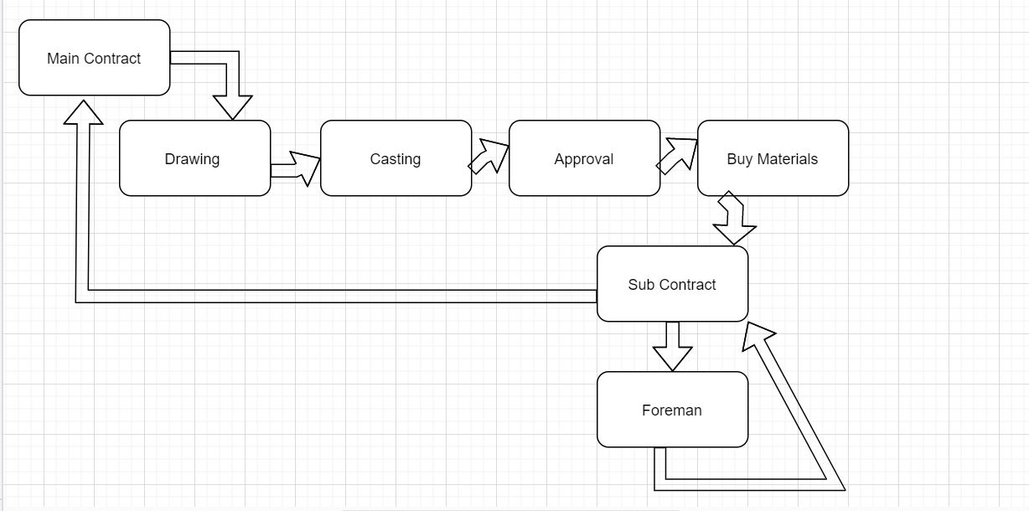

Figure :Basic Workflow of Construction Site

|  |
| --- |
| Collected Data |

1.Site Images:  
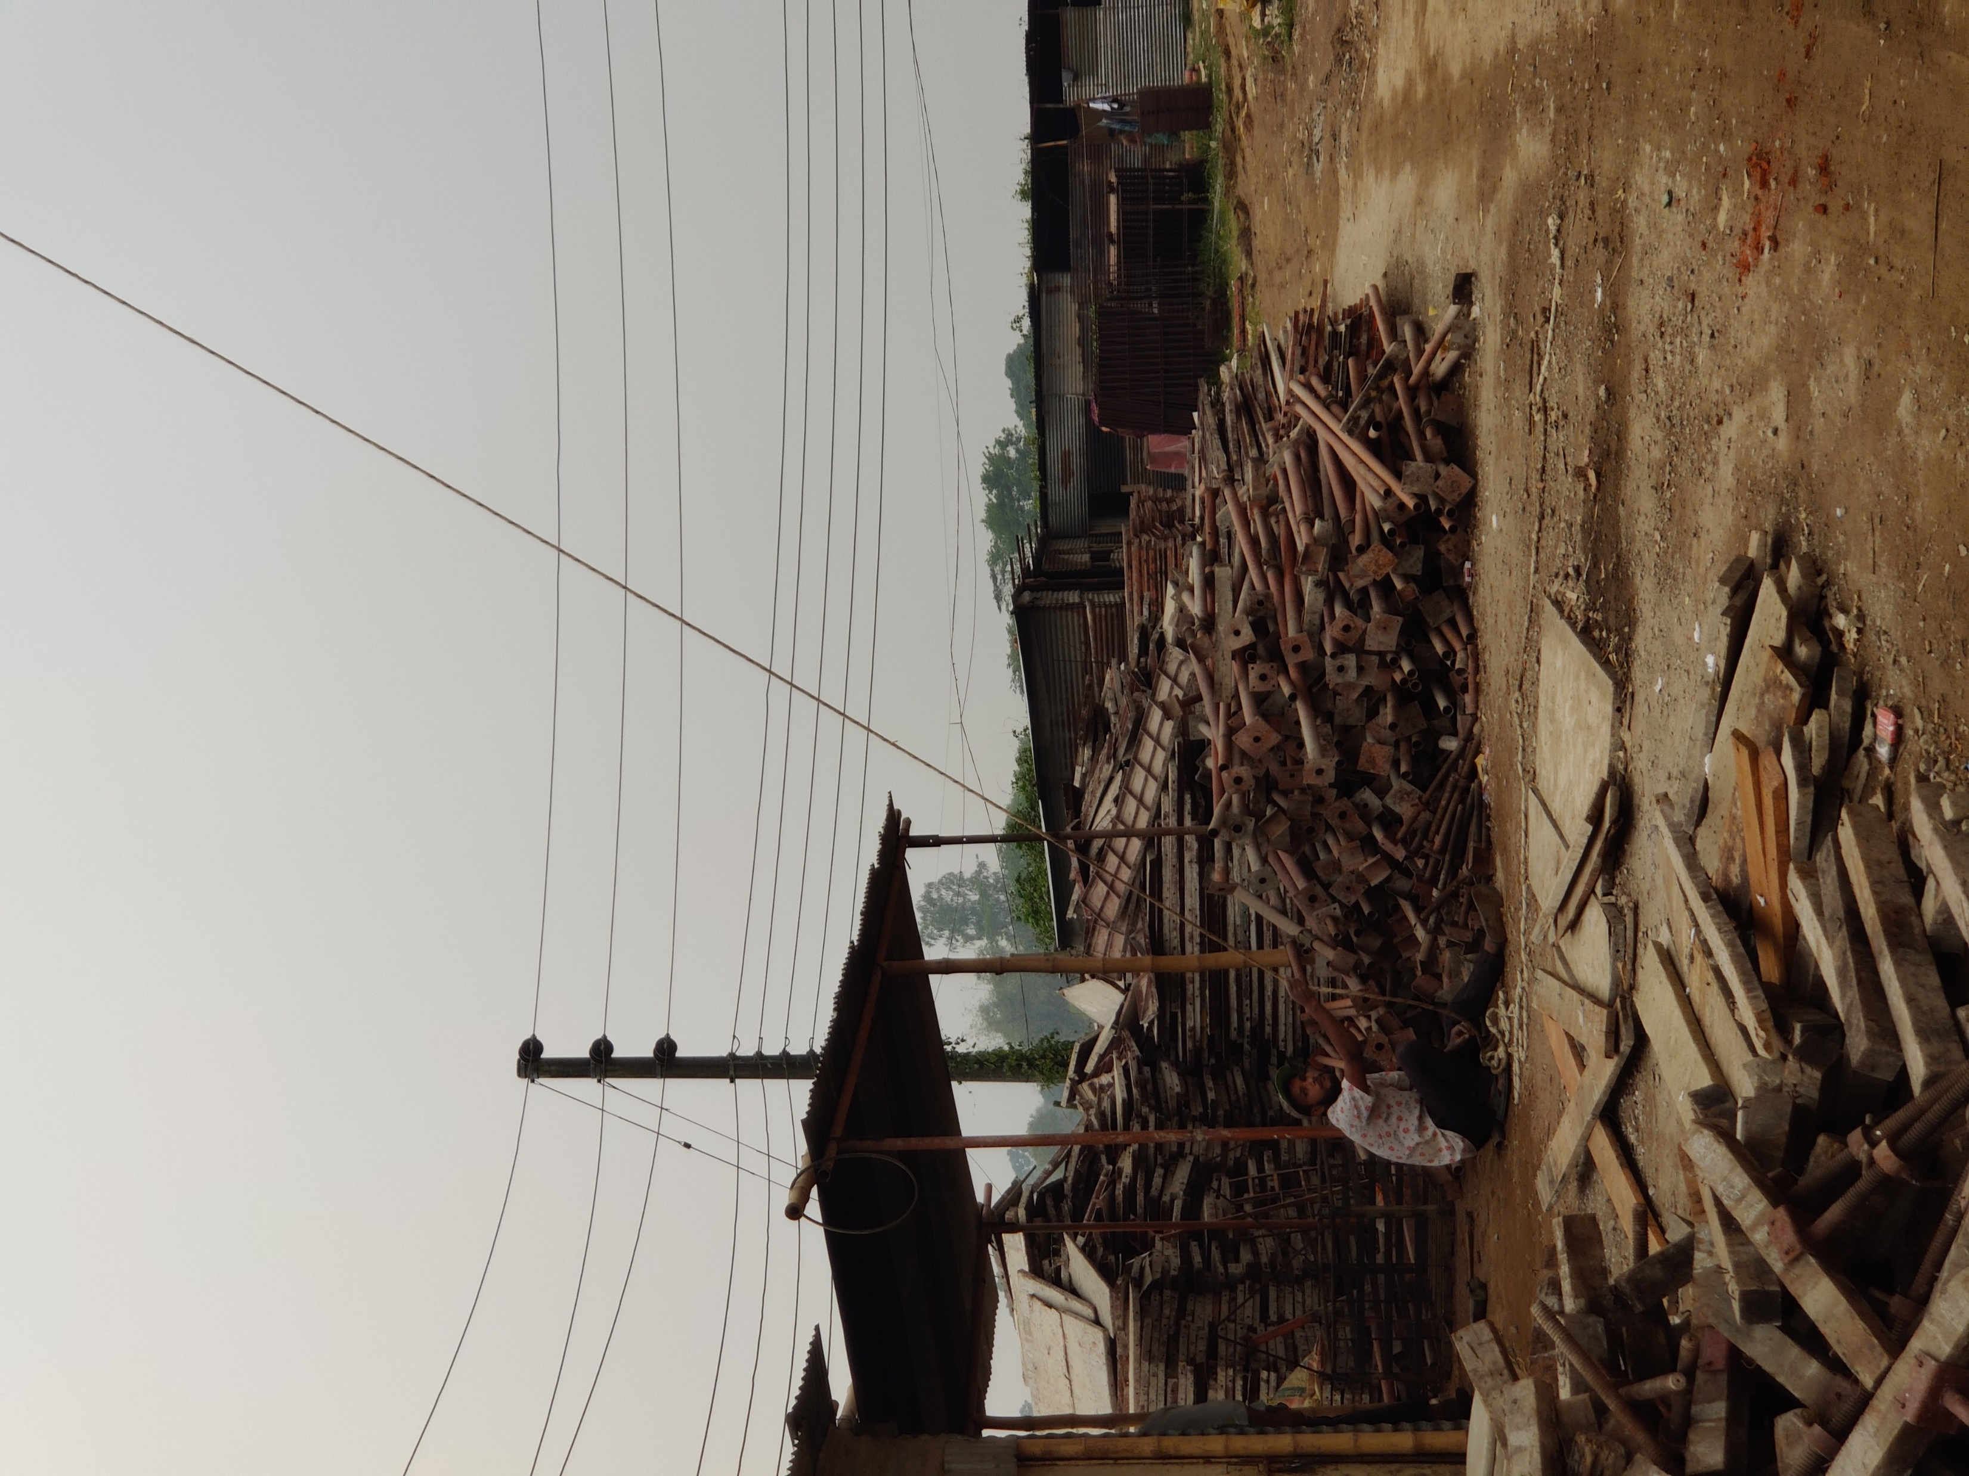

Figure :IICT Construction site Image1

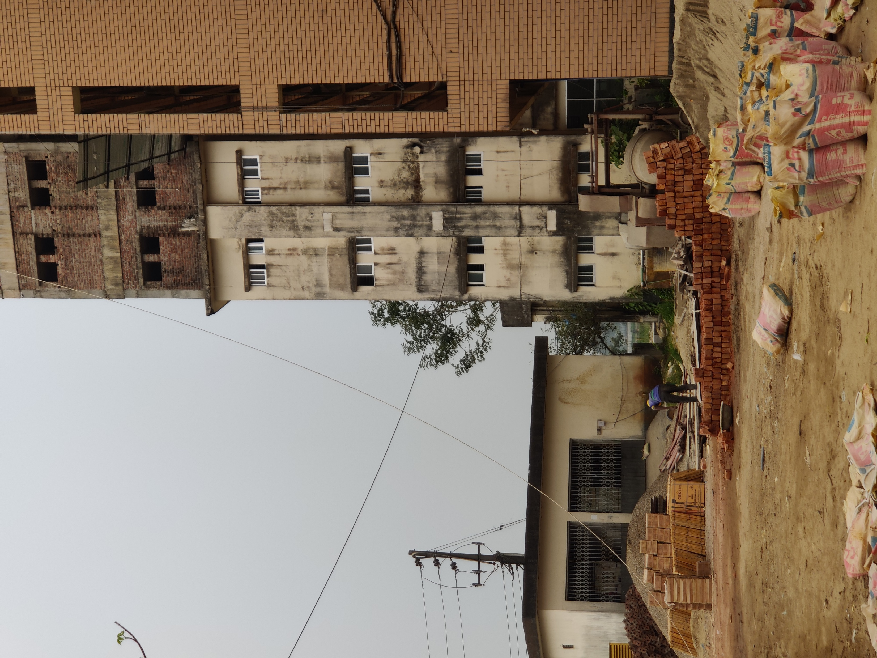

Figure :IICT Construction Site Image2

The fig-2,fig-3 shows images of the actual project of IICT construction site where the whole management system is being controlled and other necessary jobs being done.

2.Design and Approval Documents:

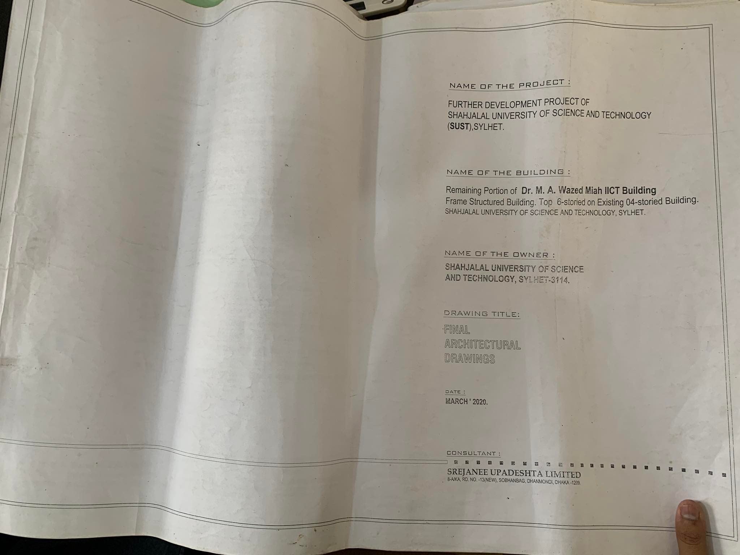

Figure :IICT_Design1

-Front Page of the Detailed Design of IICT building which includes the whole overview of the project

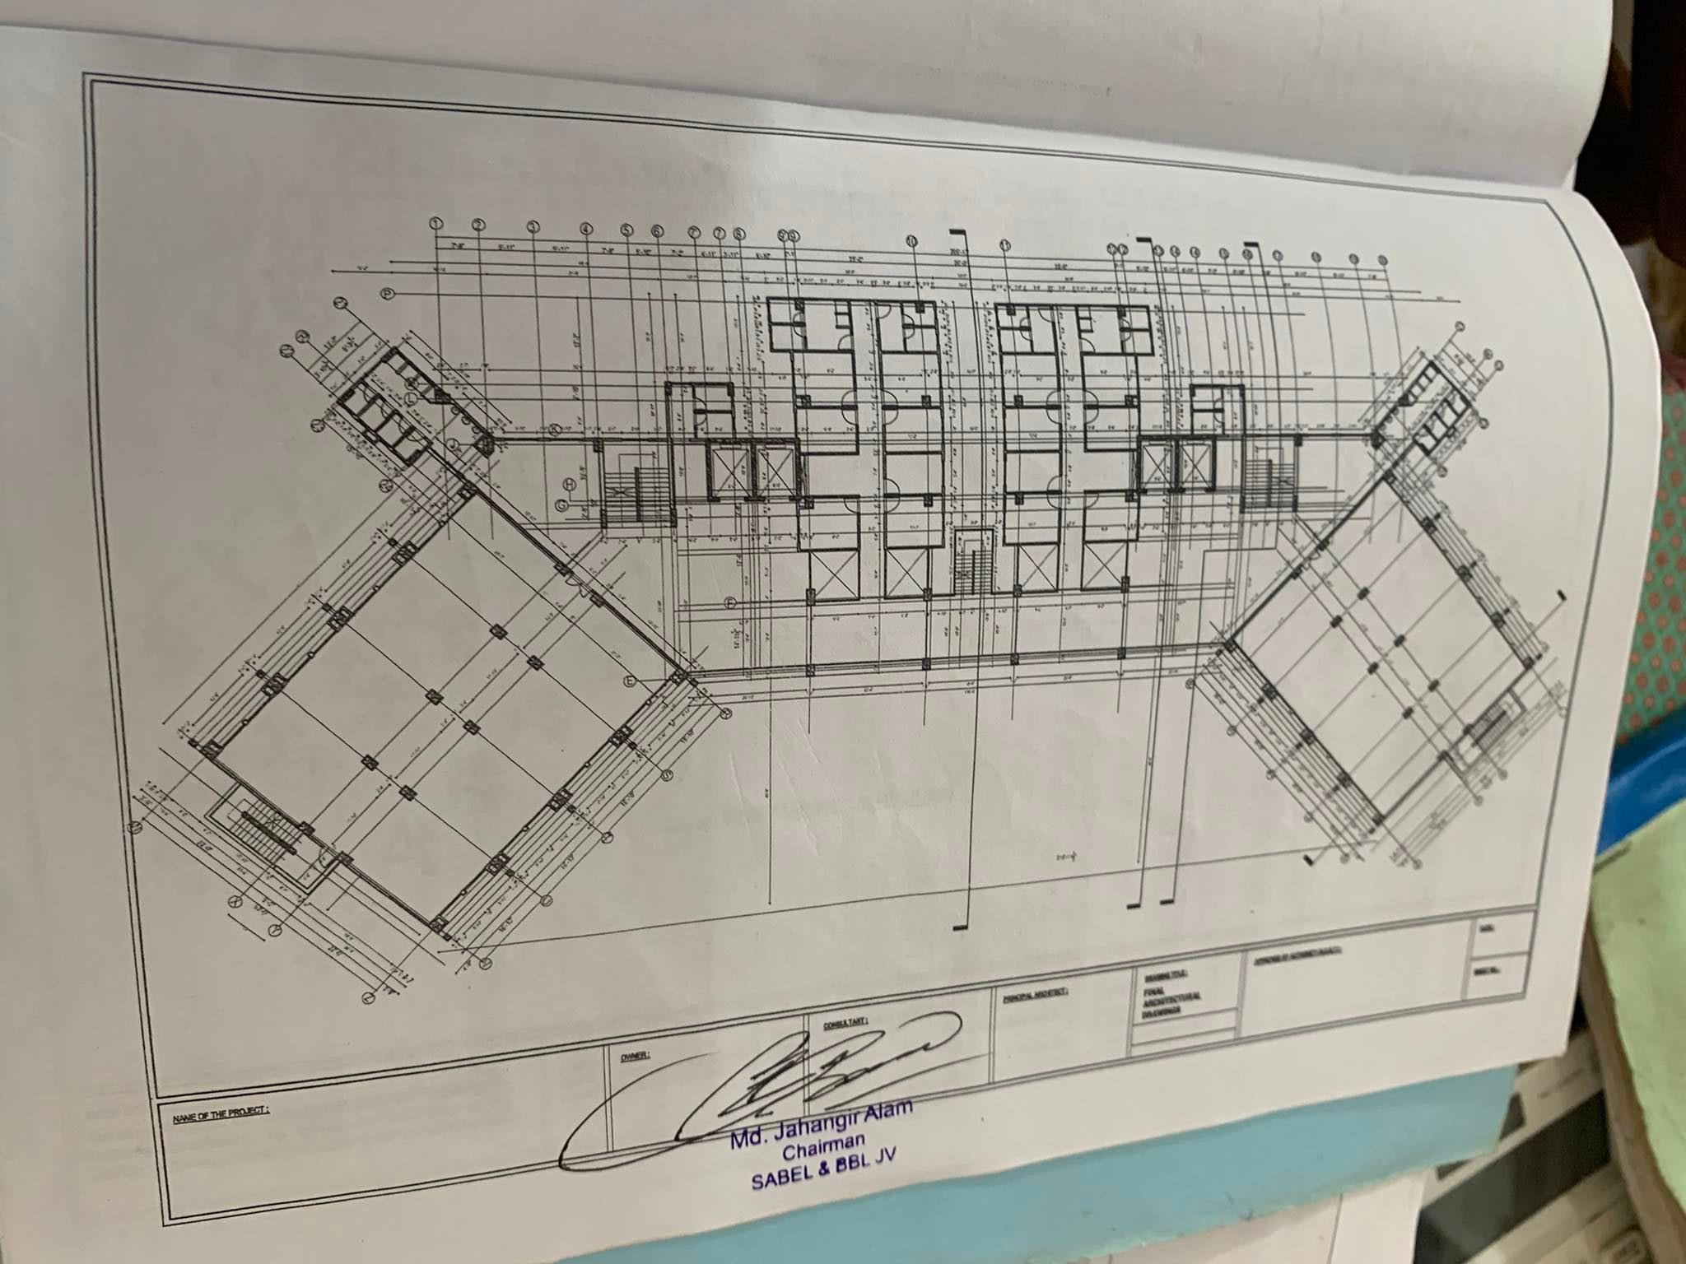

Figure :IICT Design 2

More Detailed info

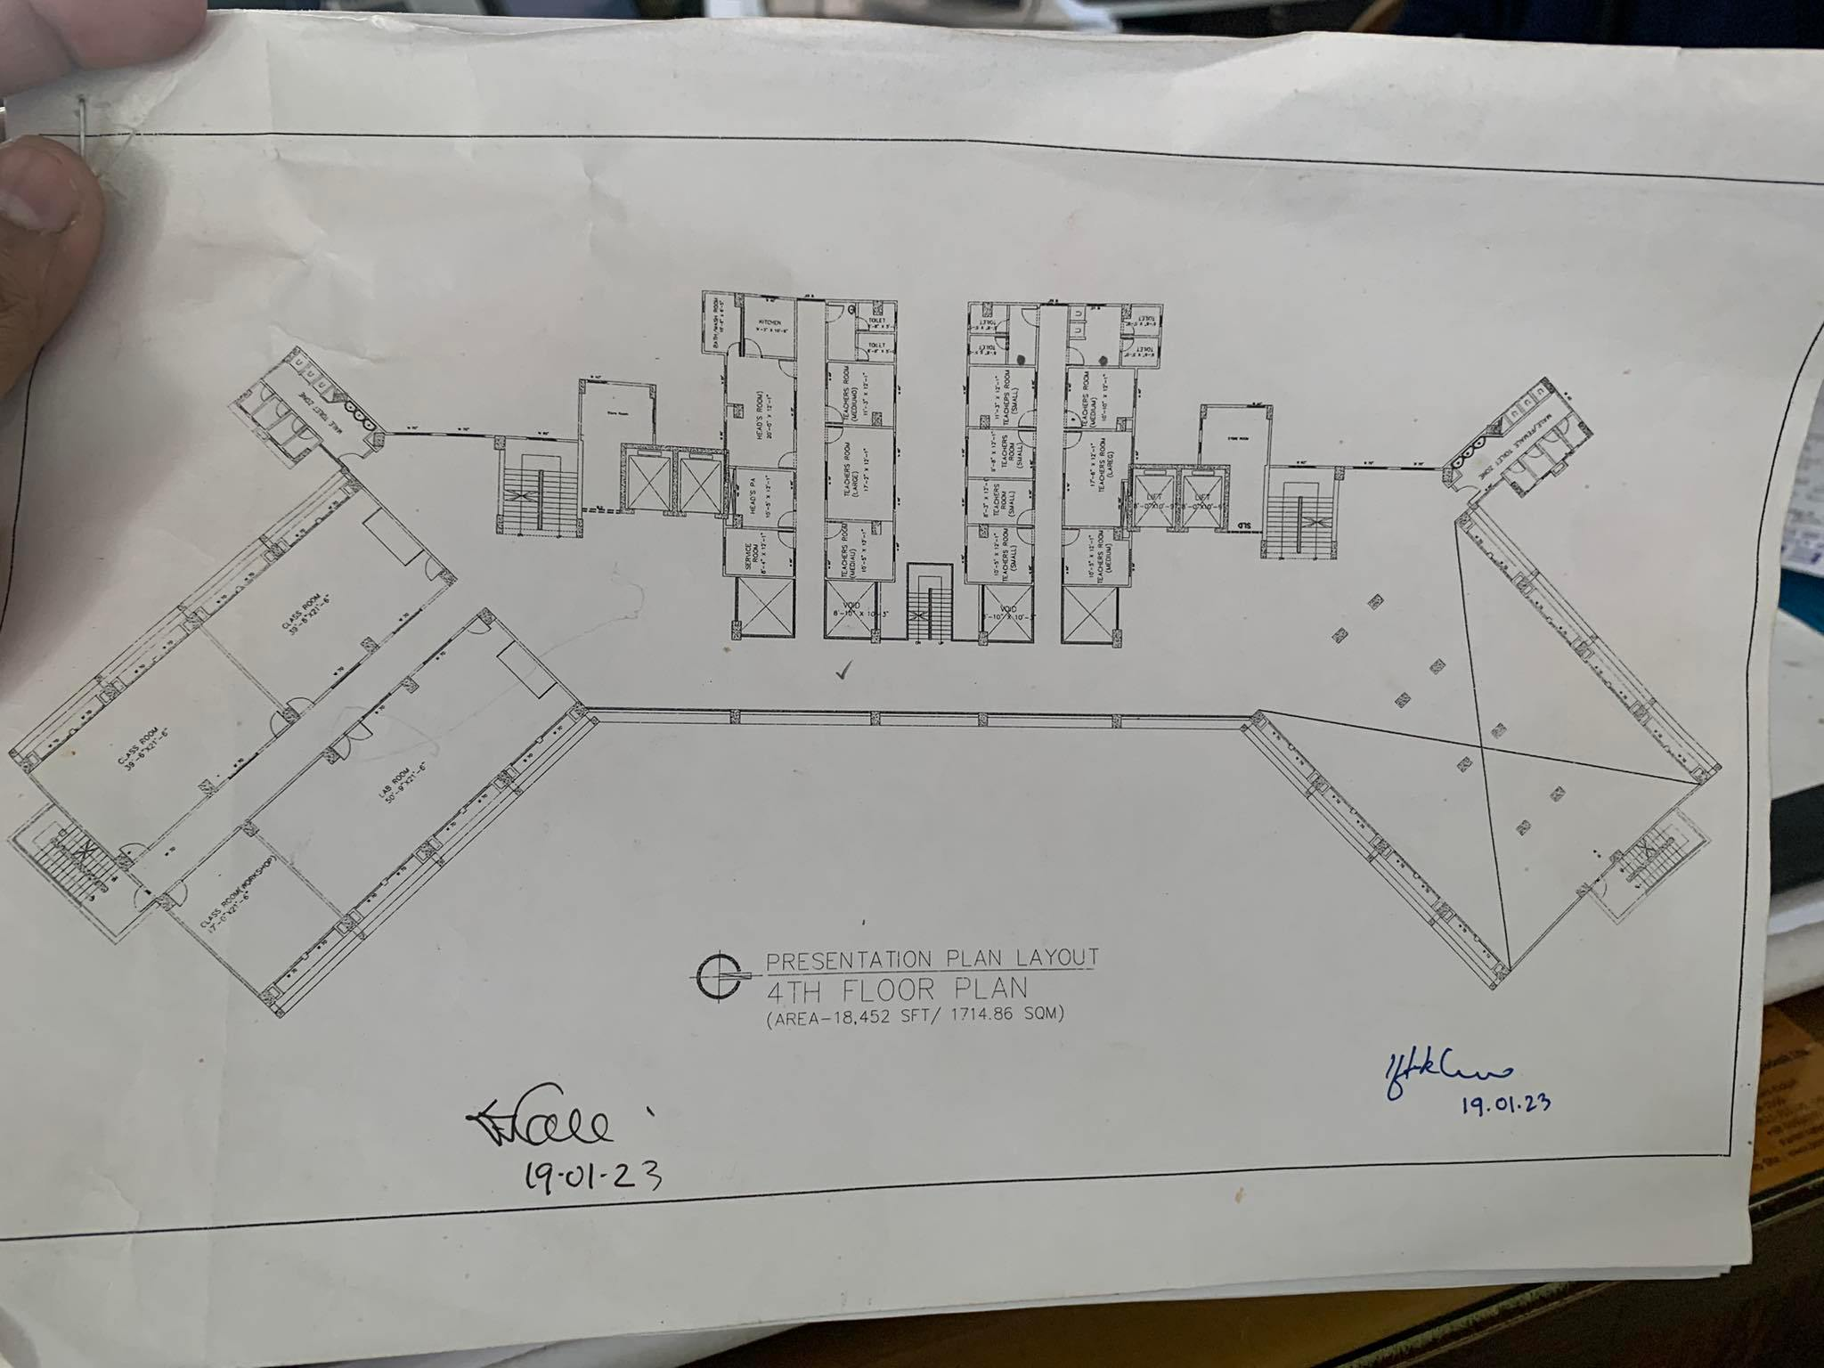

Figure :IICT design3

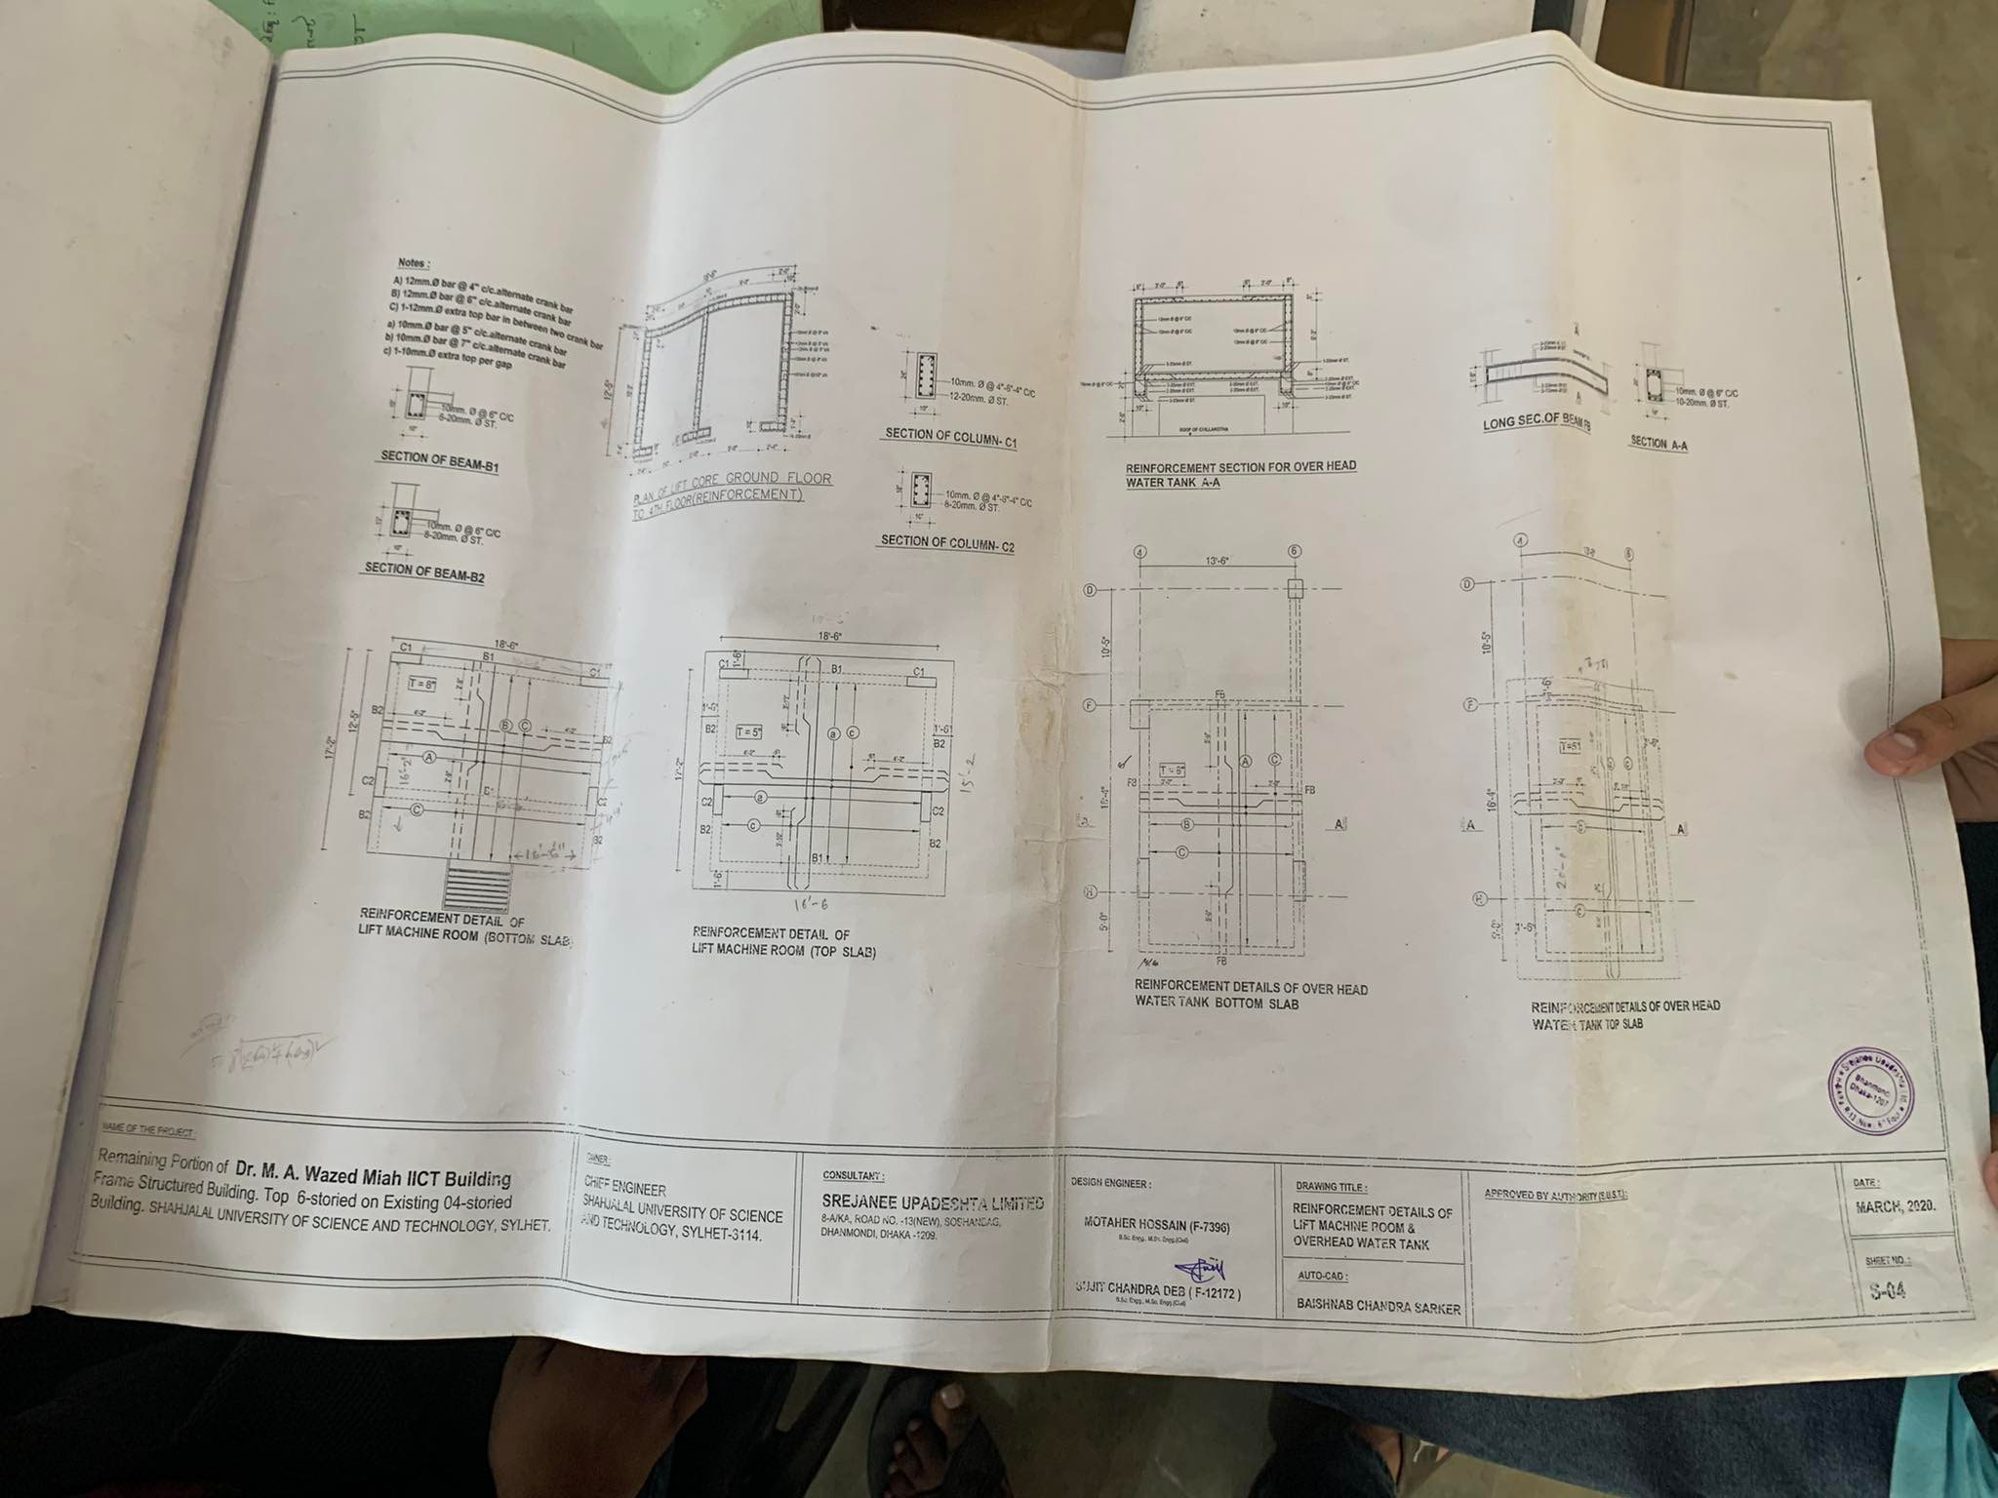 Figure : IICT design4

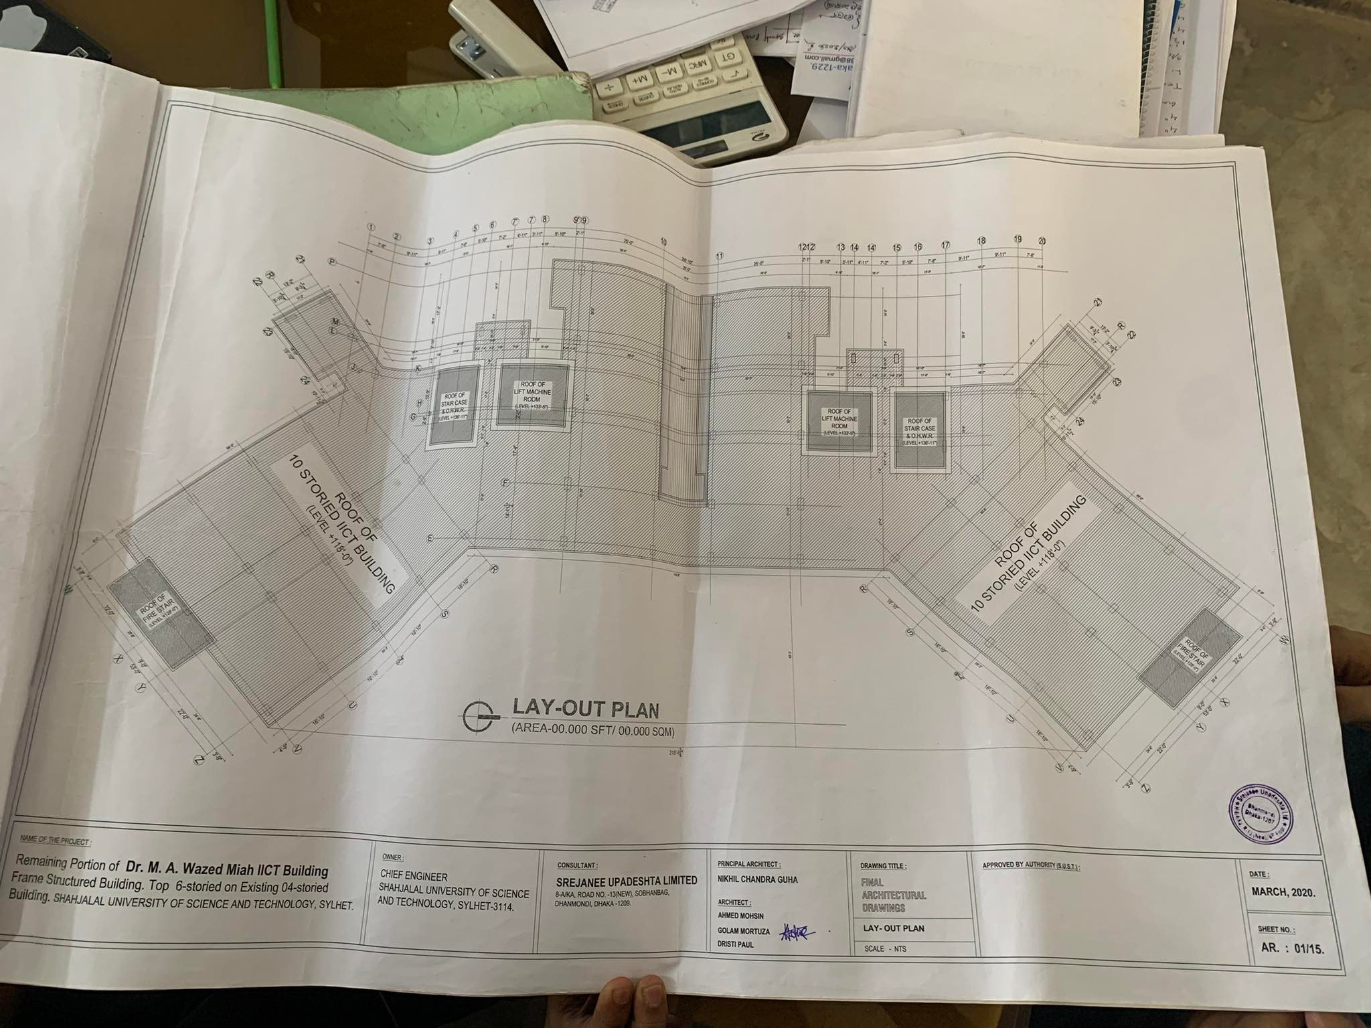

Figure :IICT Design 5

3.Account Details And Buggeting Details:

This mainly gives the account and budget of the whole project

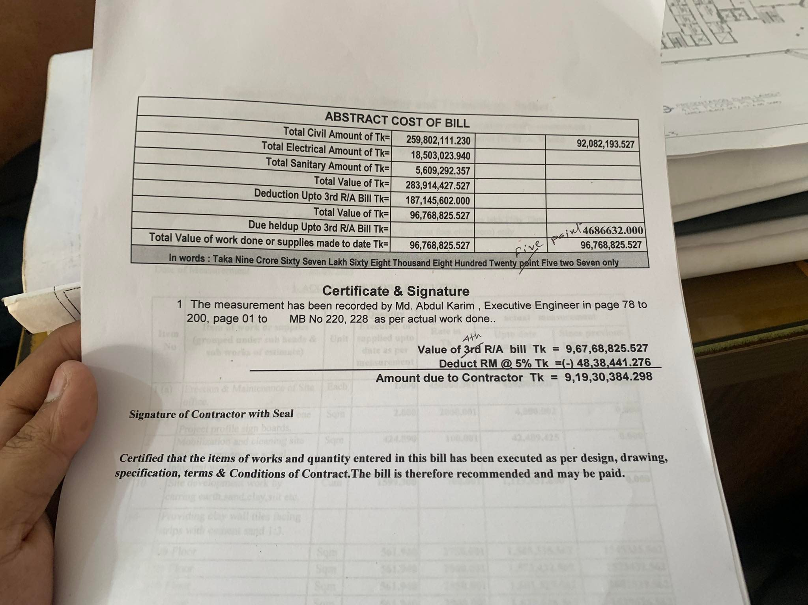

Figure Account-1

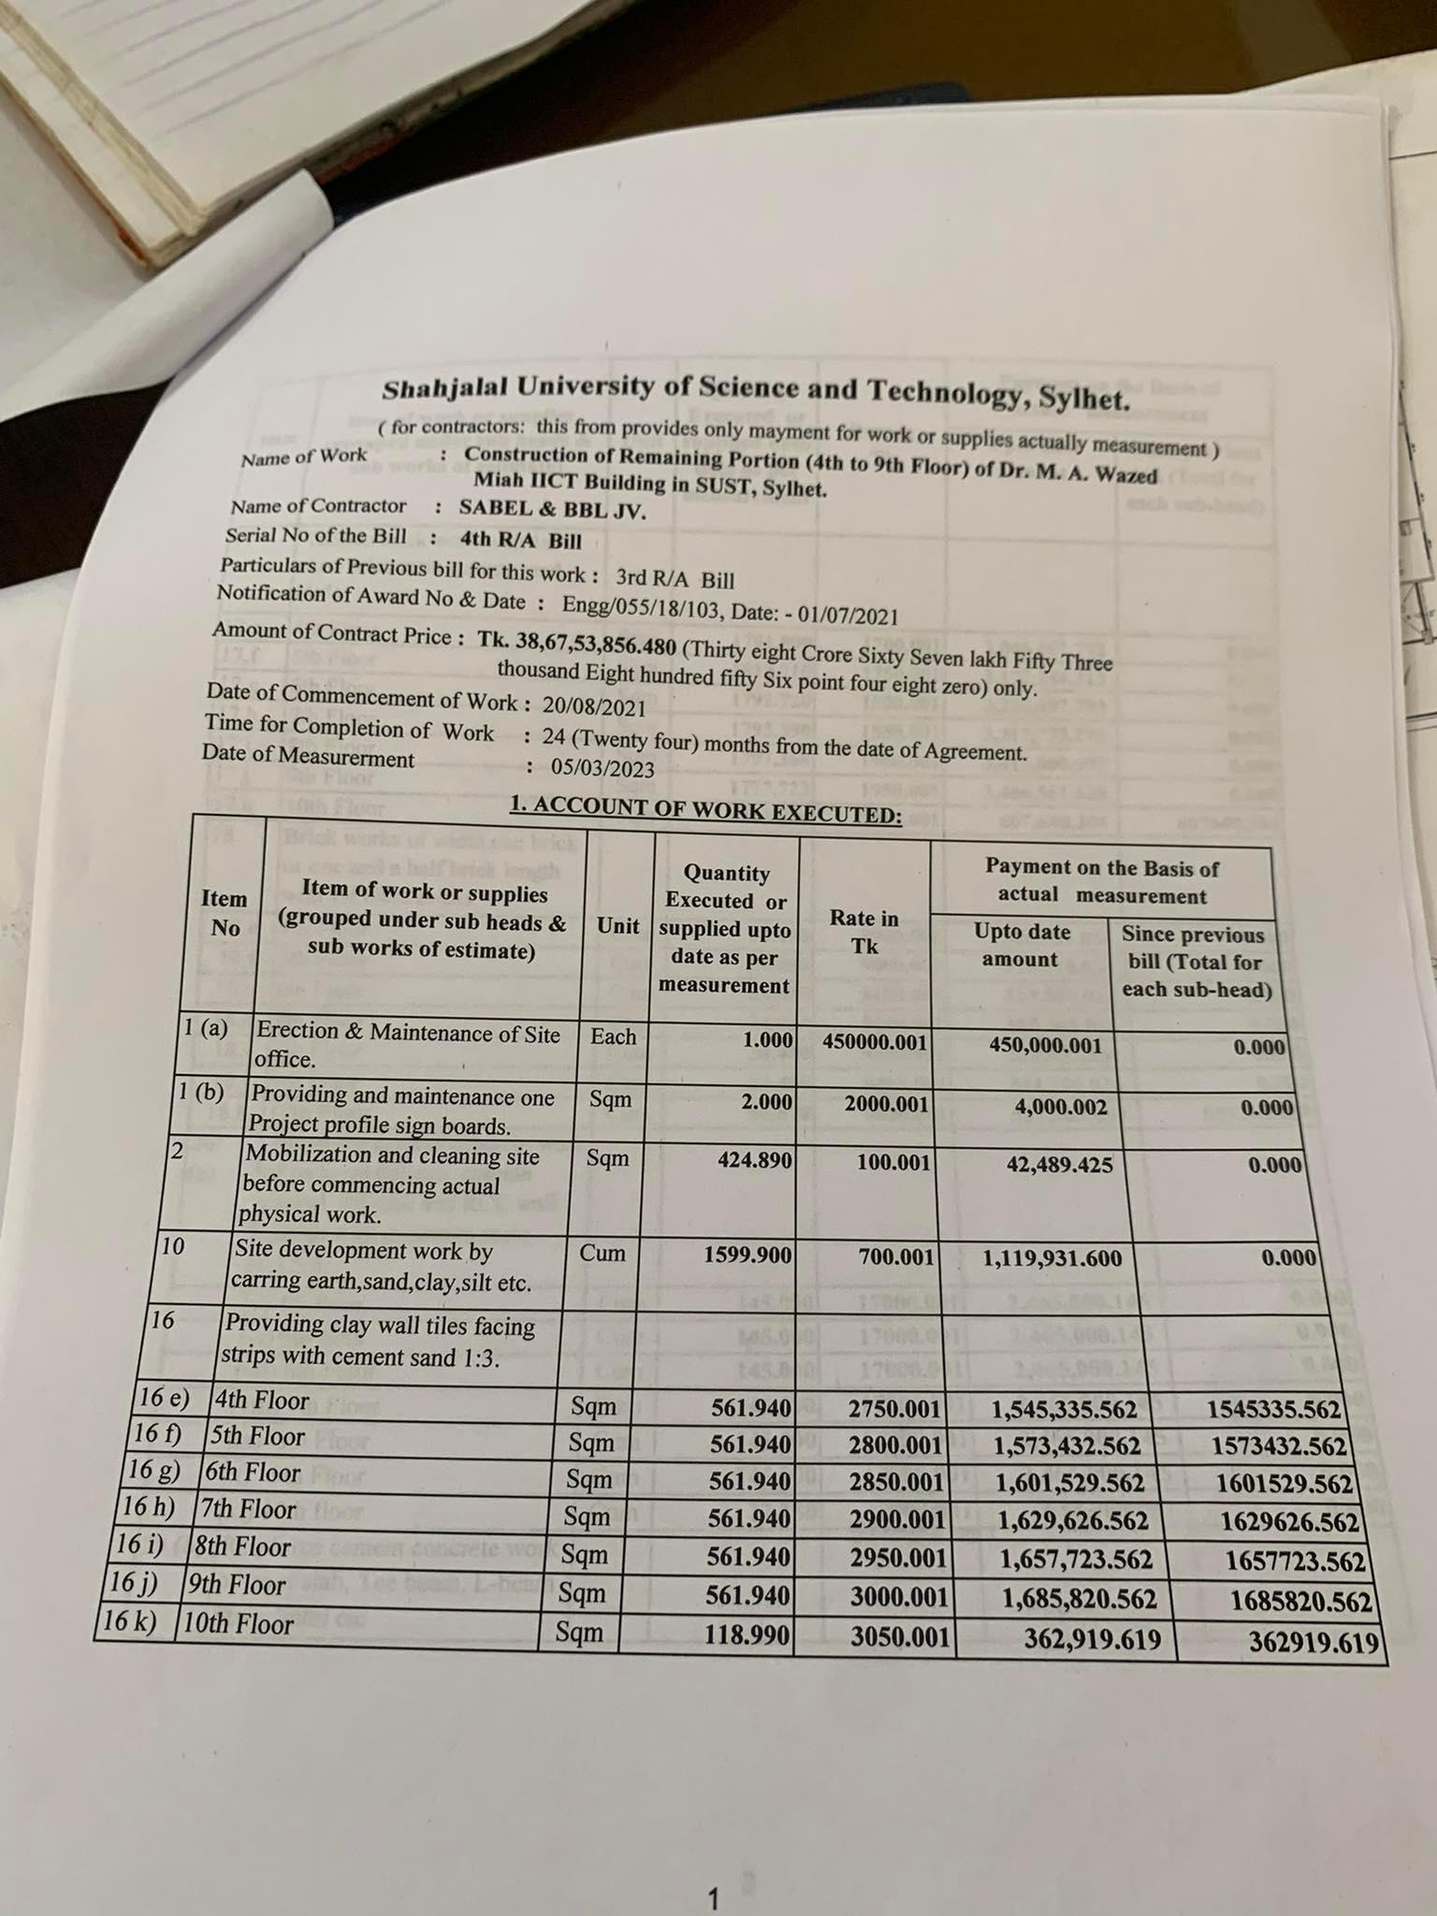

Figure :Account-2

4.Tender Info:

It provides the information of how the company gets the contract from the authority

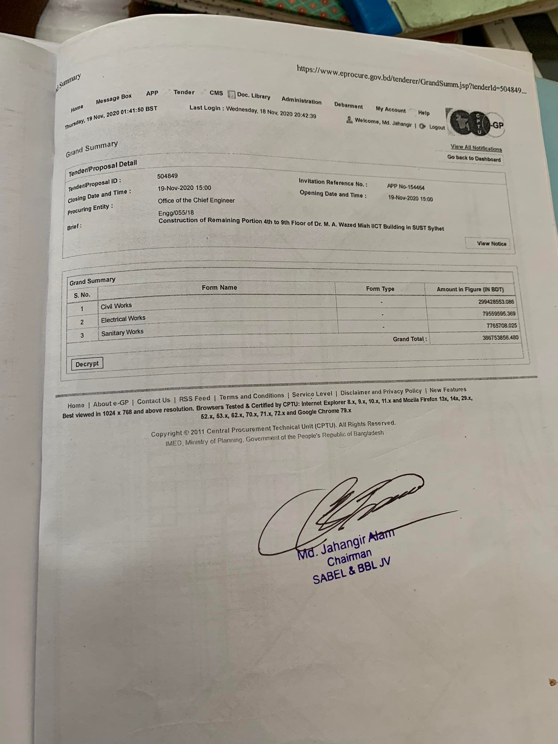

Figure :Tender

5.Official ,Staff and Worker Info(Salary):  
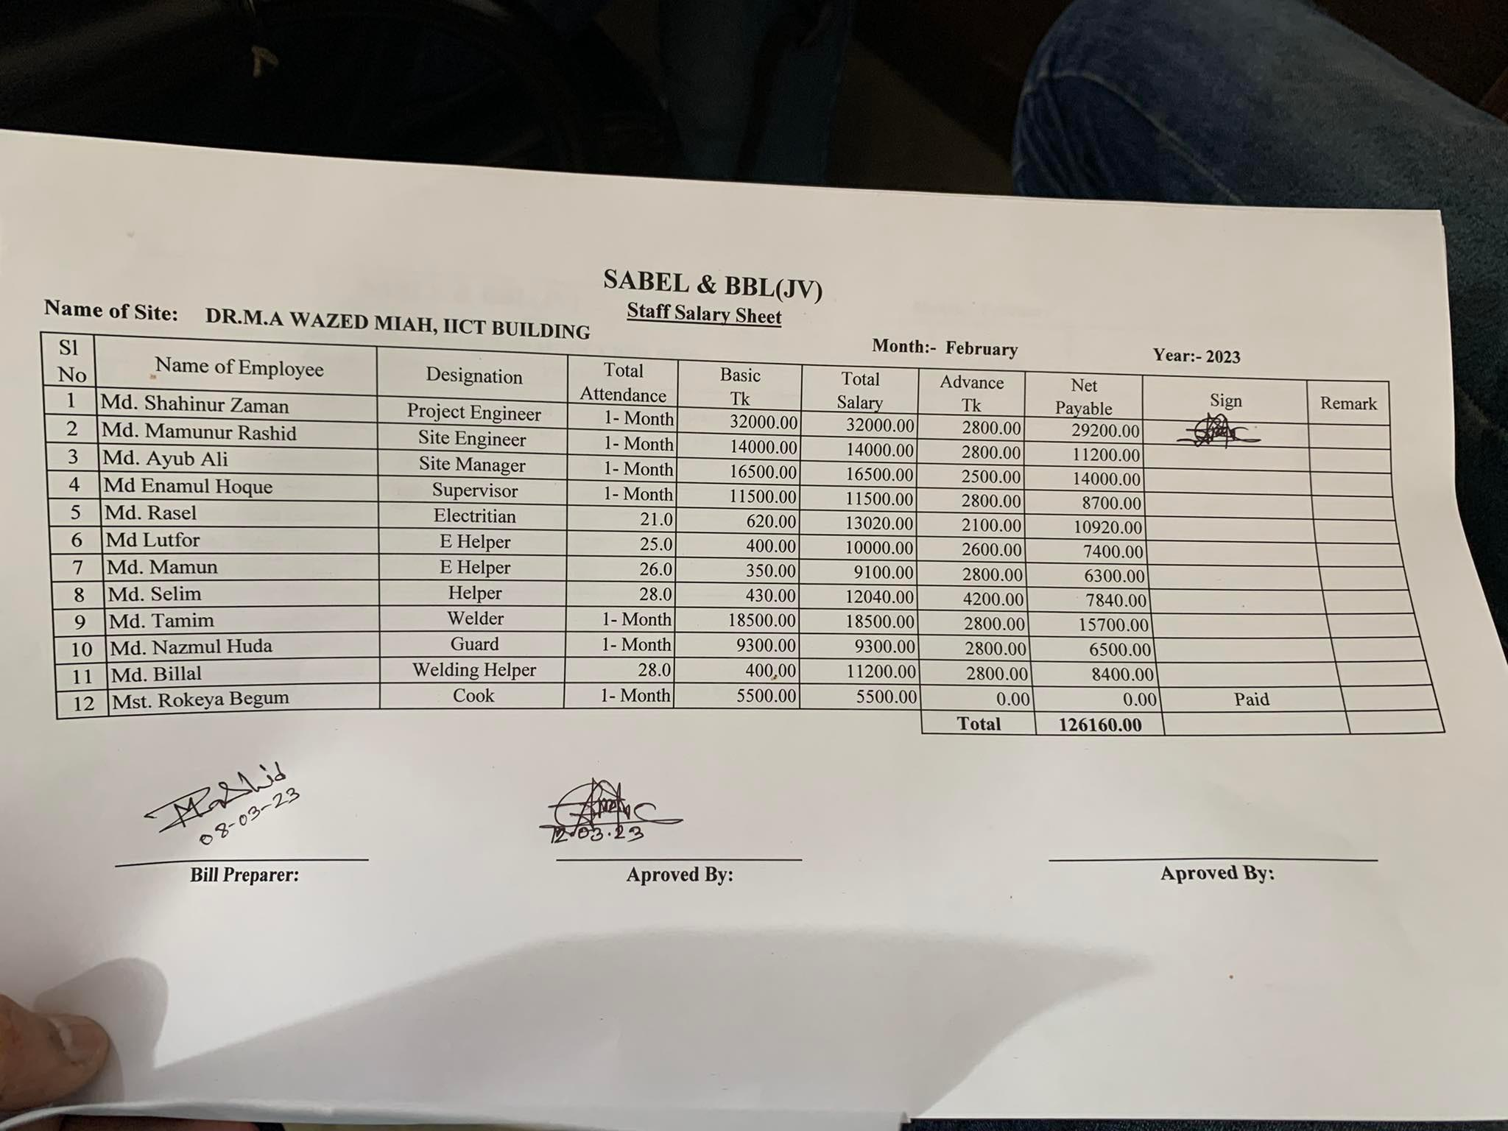

Figure : Officials

Provides Details of the officials working here

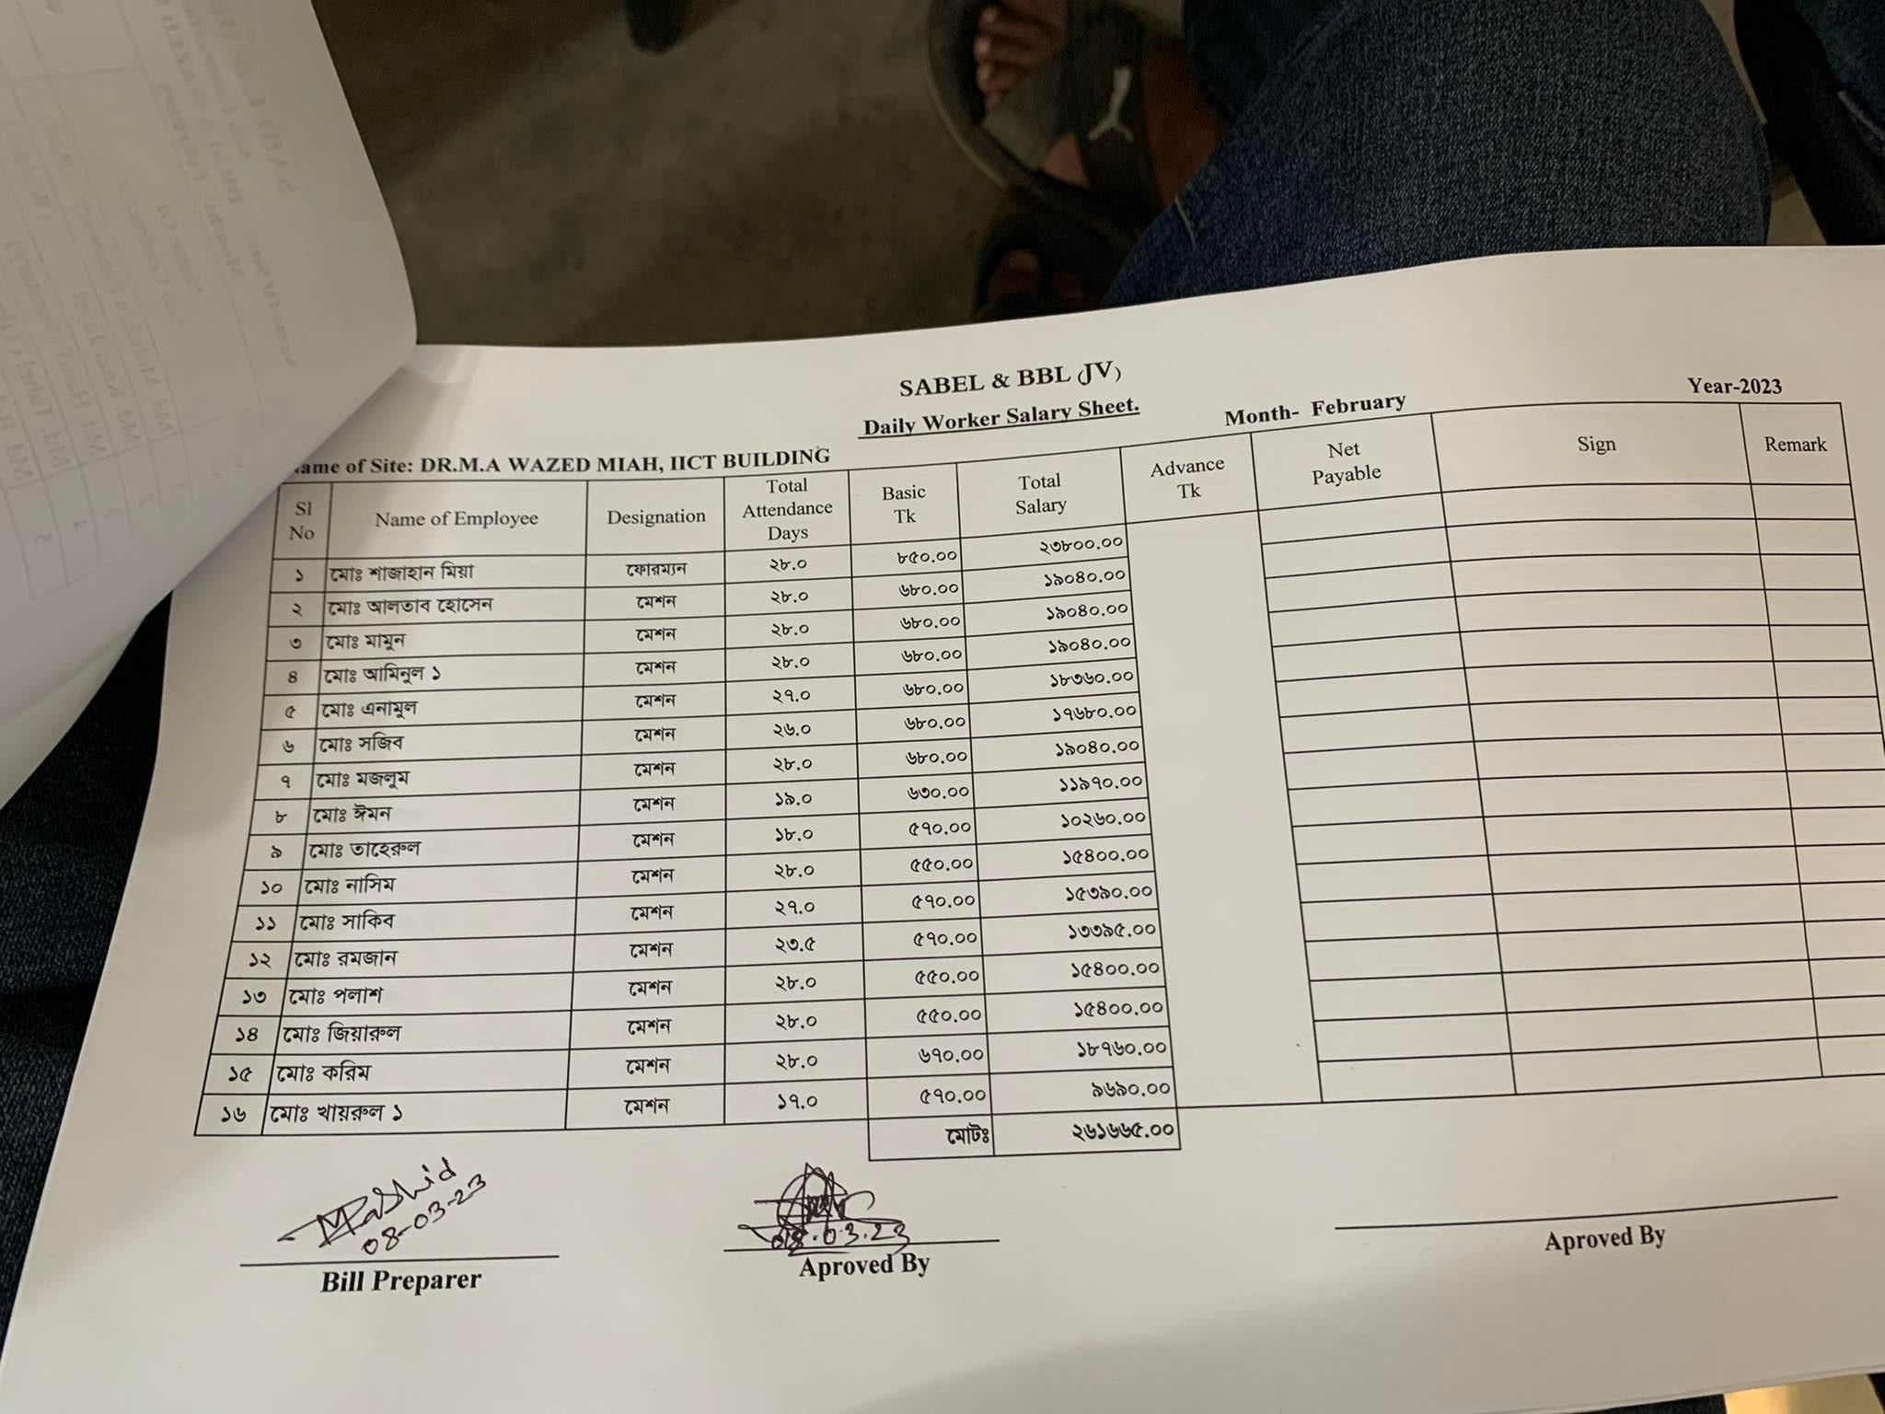

Figure :Staff Salary

6.Project Detail Planning (Costing)

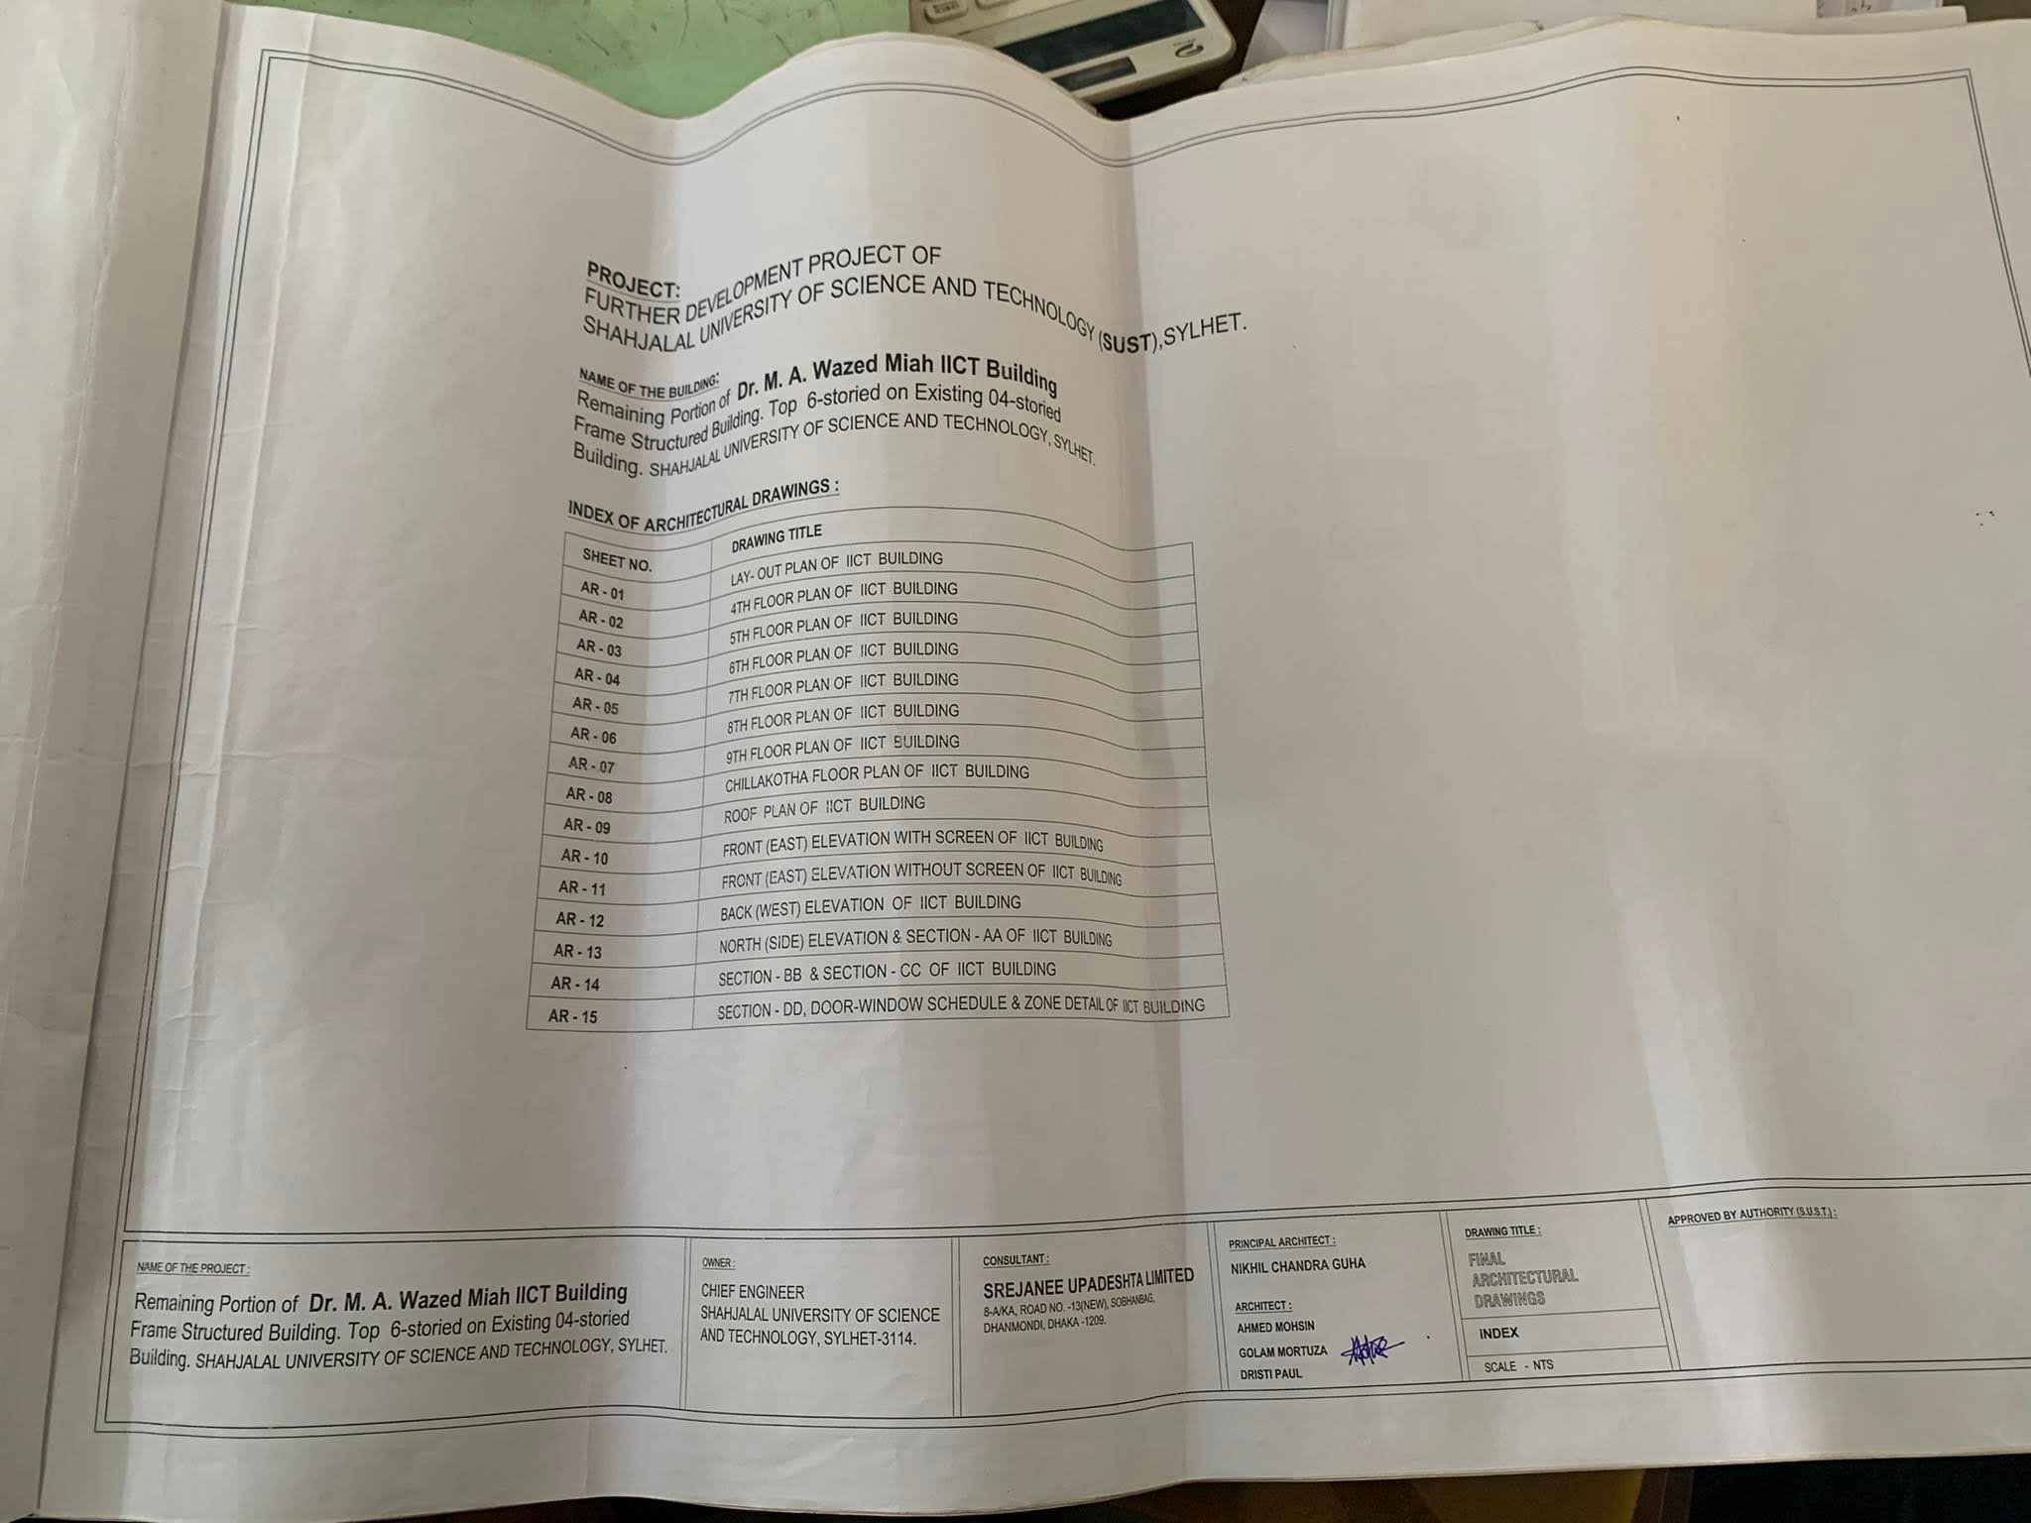

Figure :Project Planning1

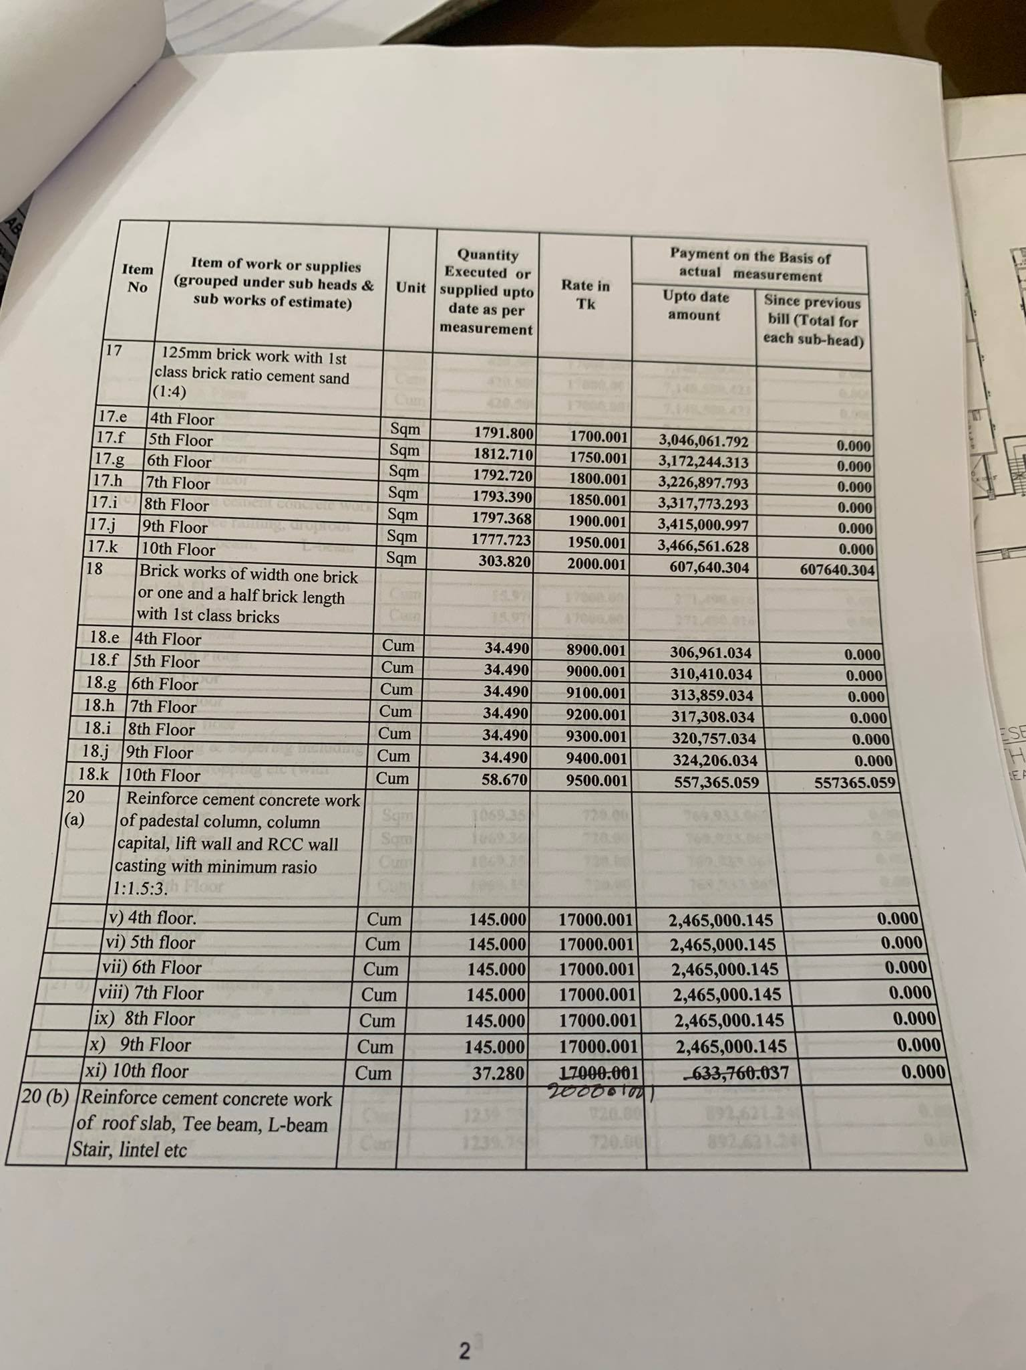

Figure :Project Planning2

1.Raw Material Inventory And Purchasing Process:

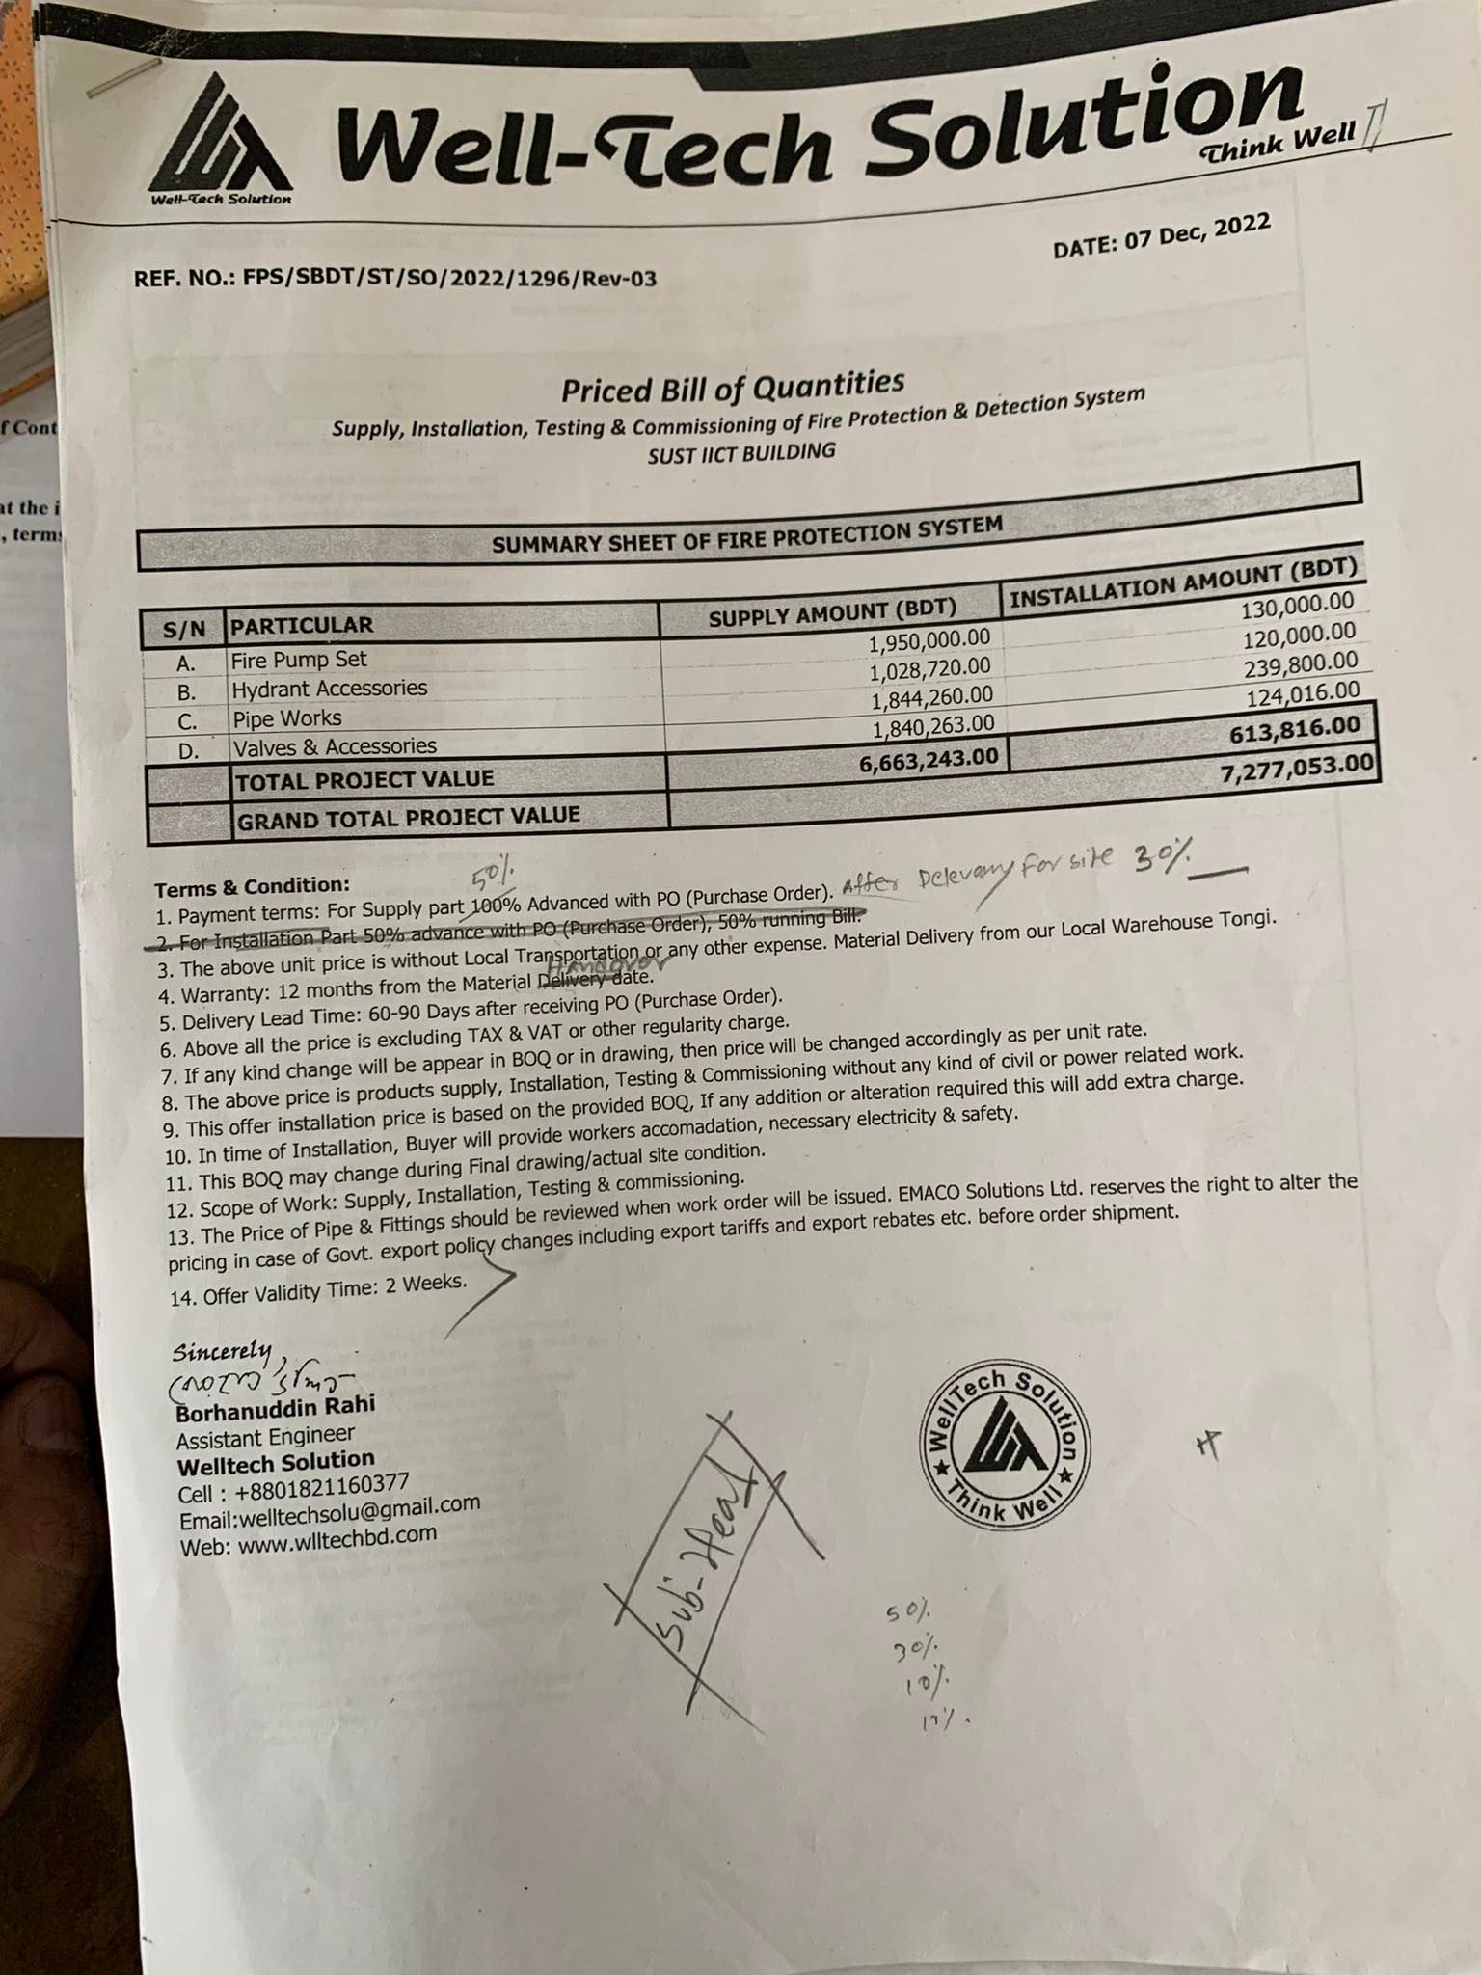

Figure16:Requirement Sending to purchase

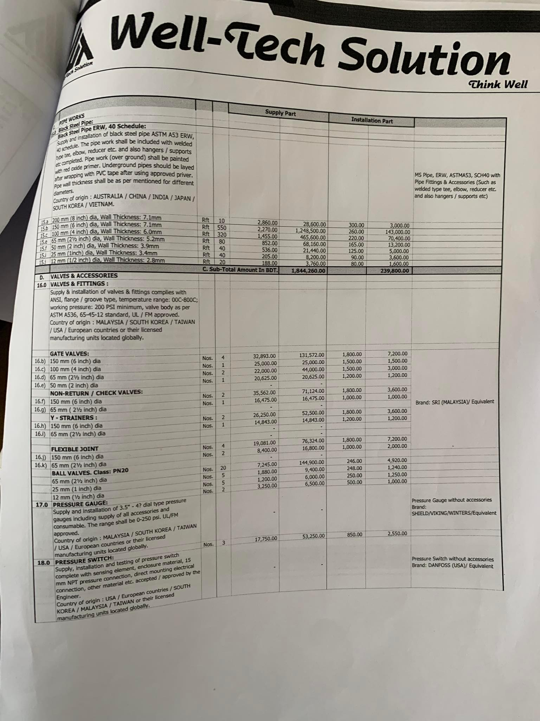

Figure 17:Requirement Sending2

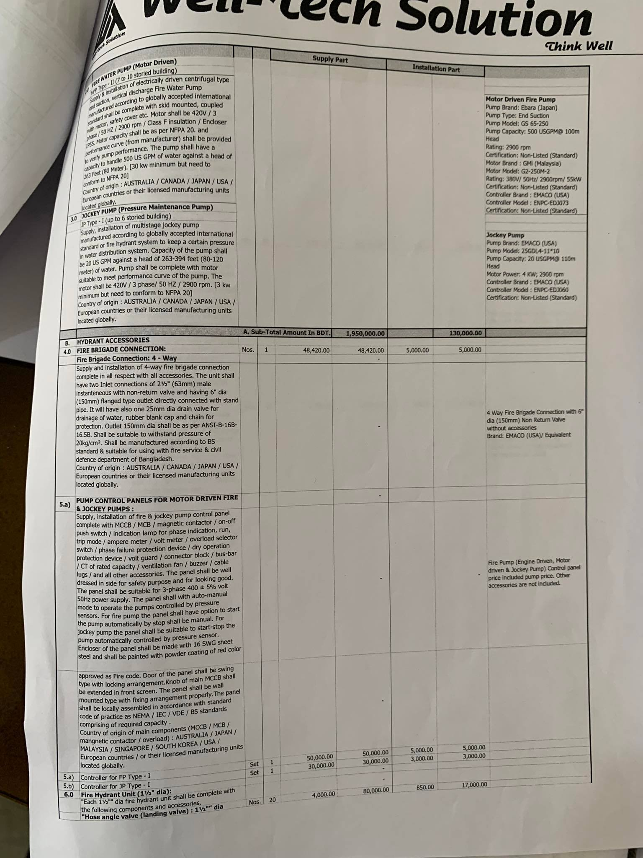

Figure 18: Requirement Sending 3

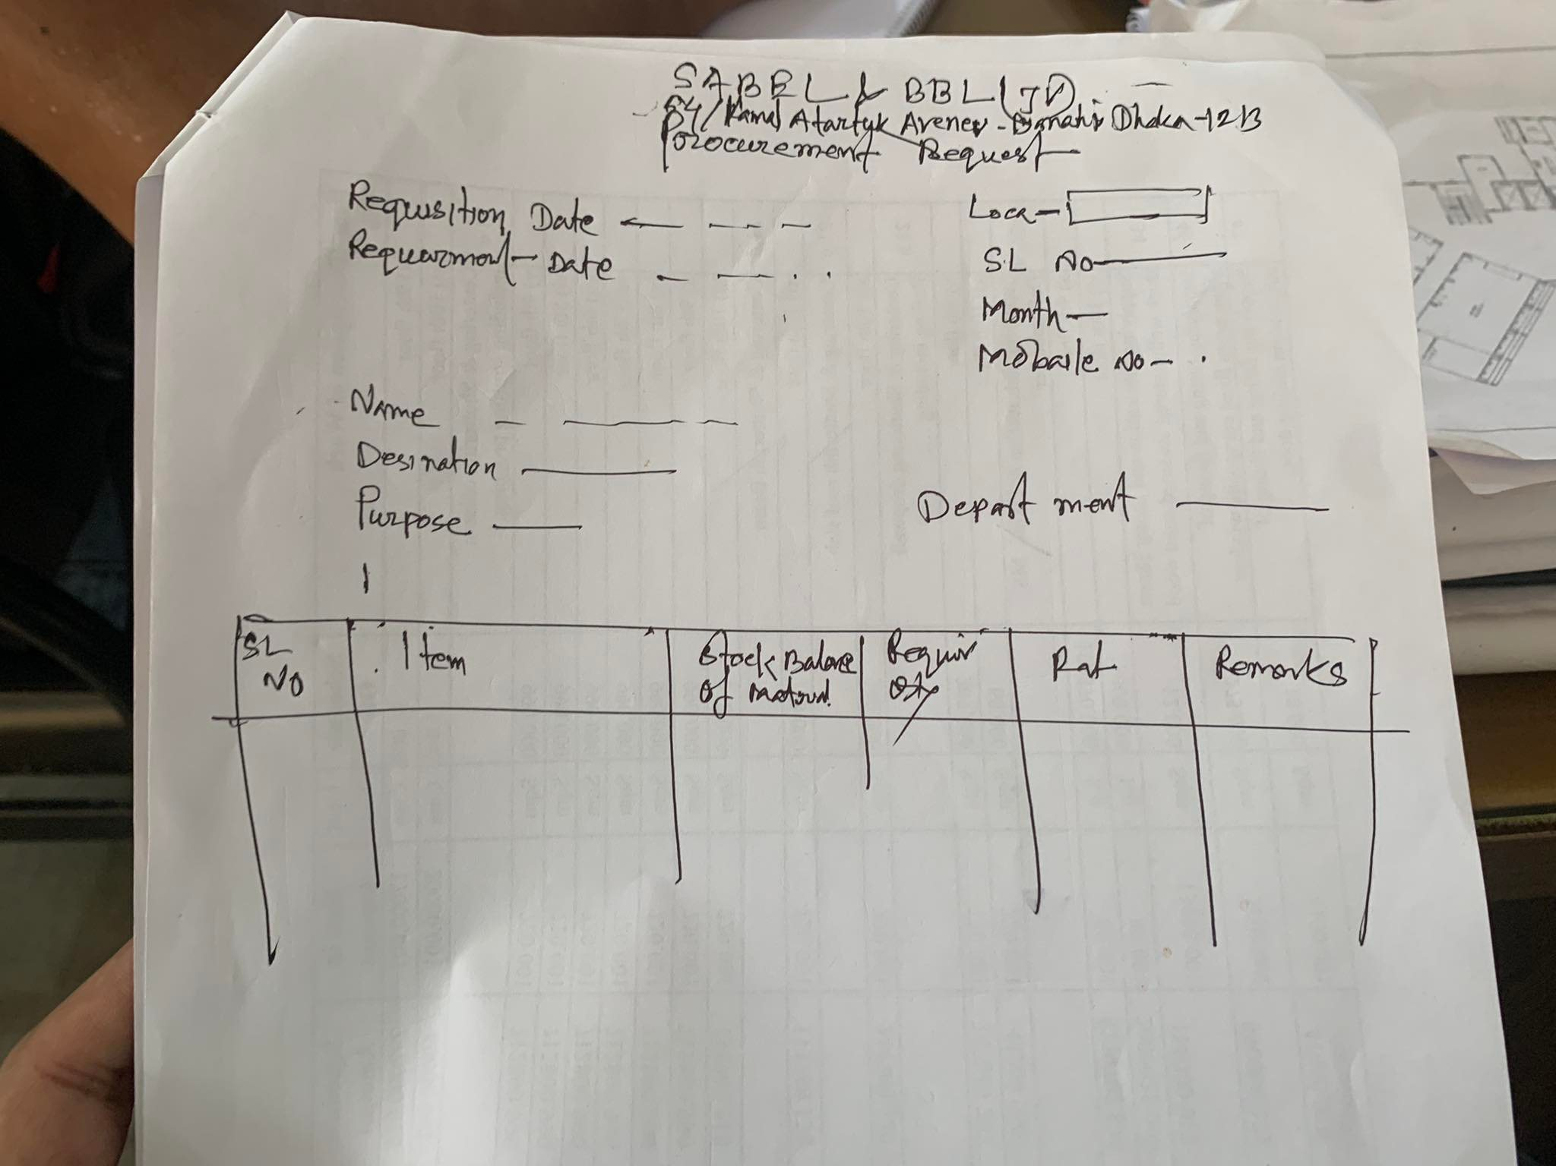

Figure 19:Requirement Form

8.Raw Material Receiving Process And Bill payement:

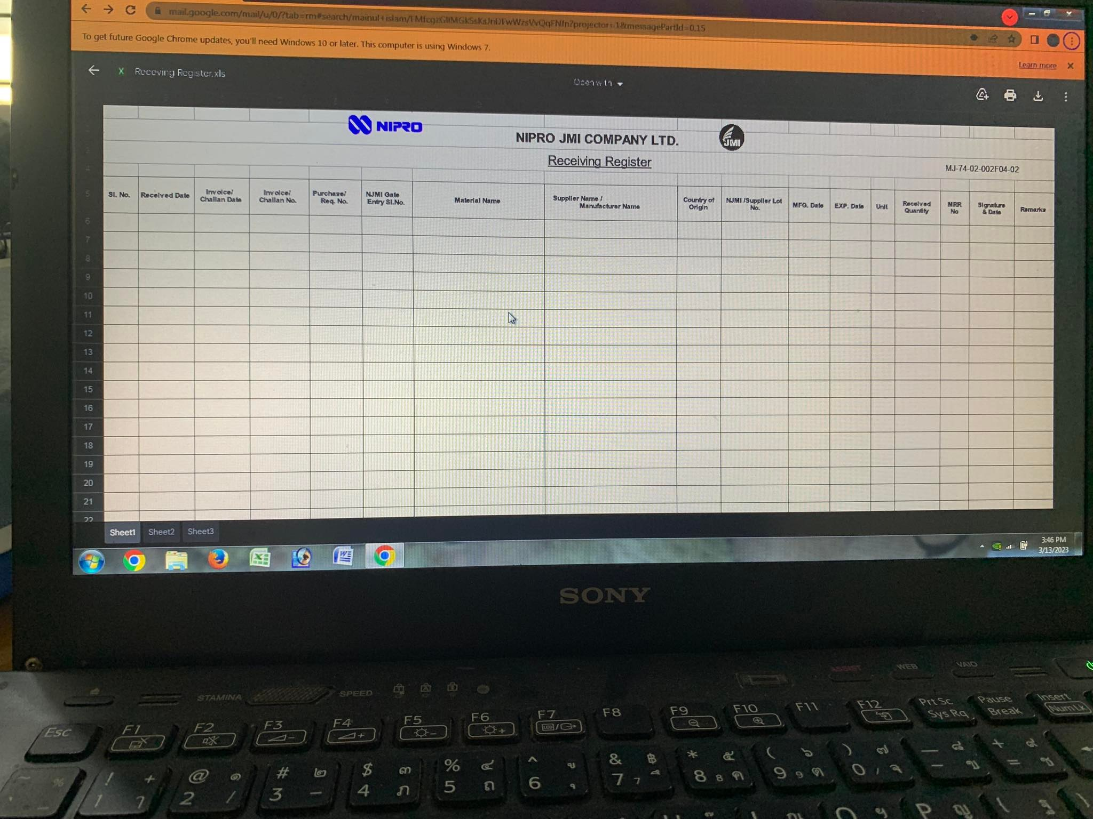

Figure 20:Raw MateriaL Recieving Form

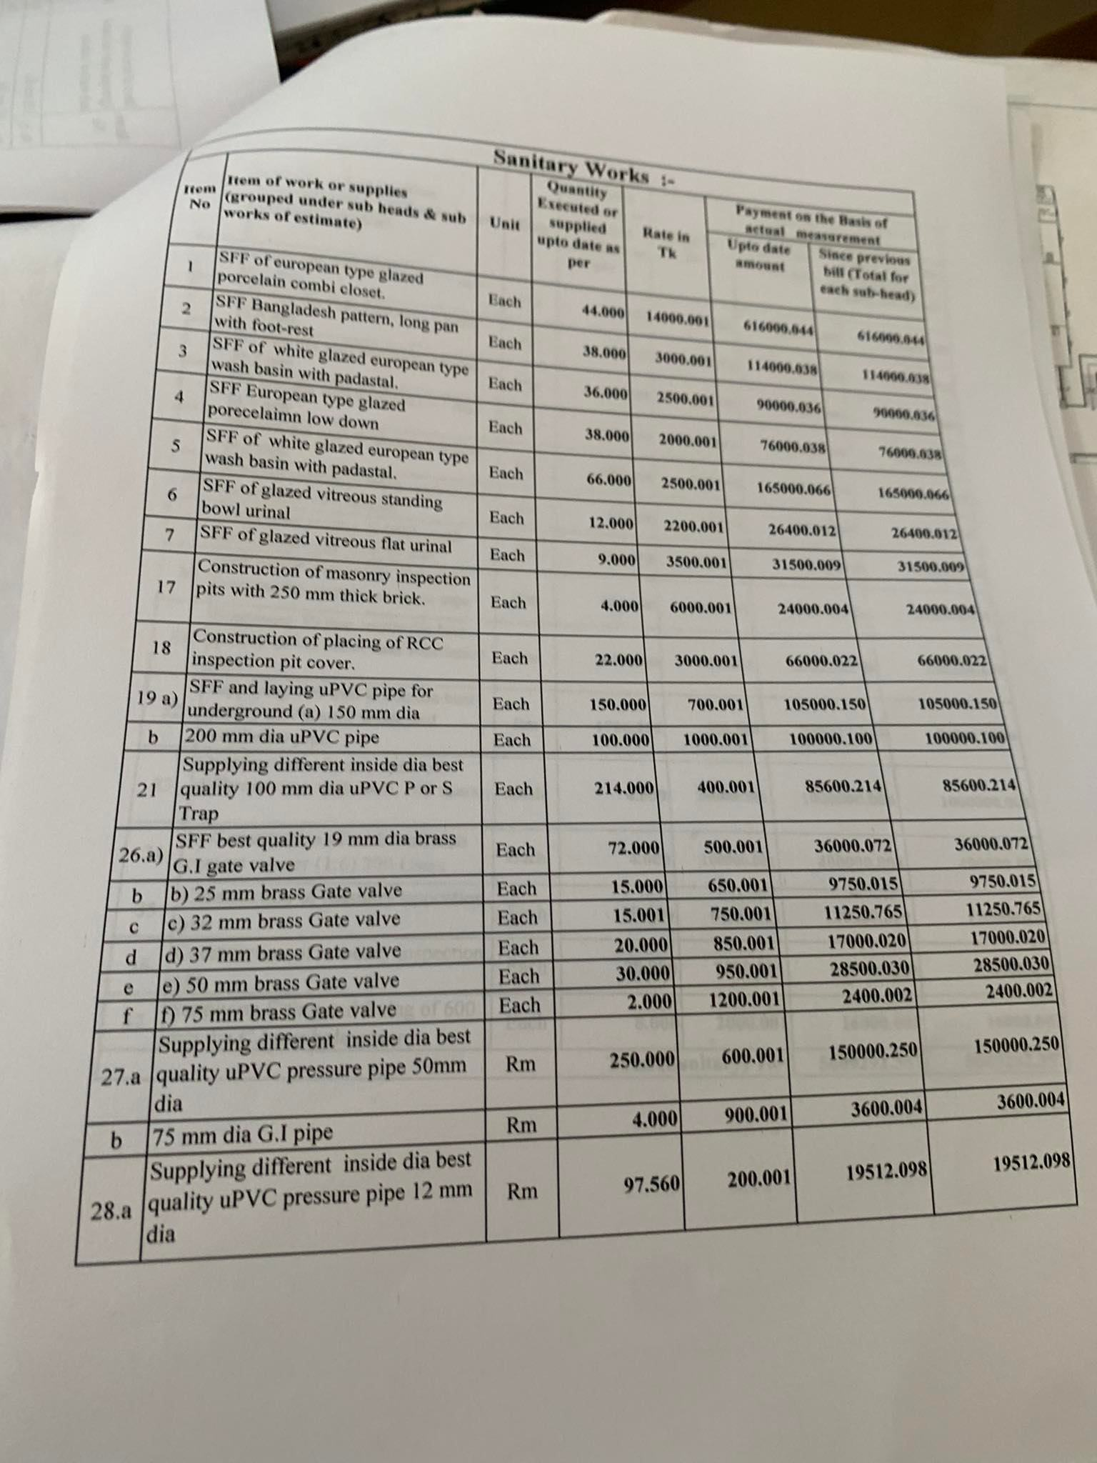

Figure 21 : Raw Material Bill(Sanitary)

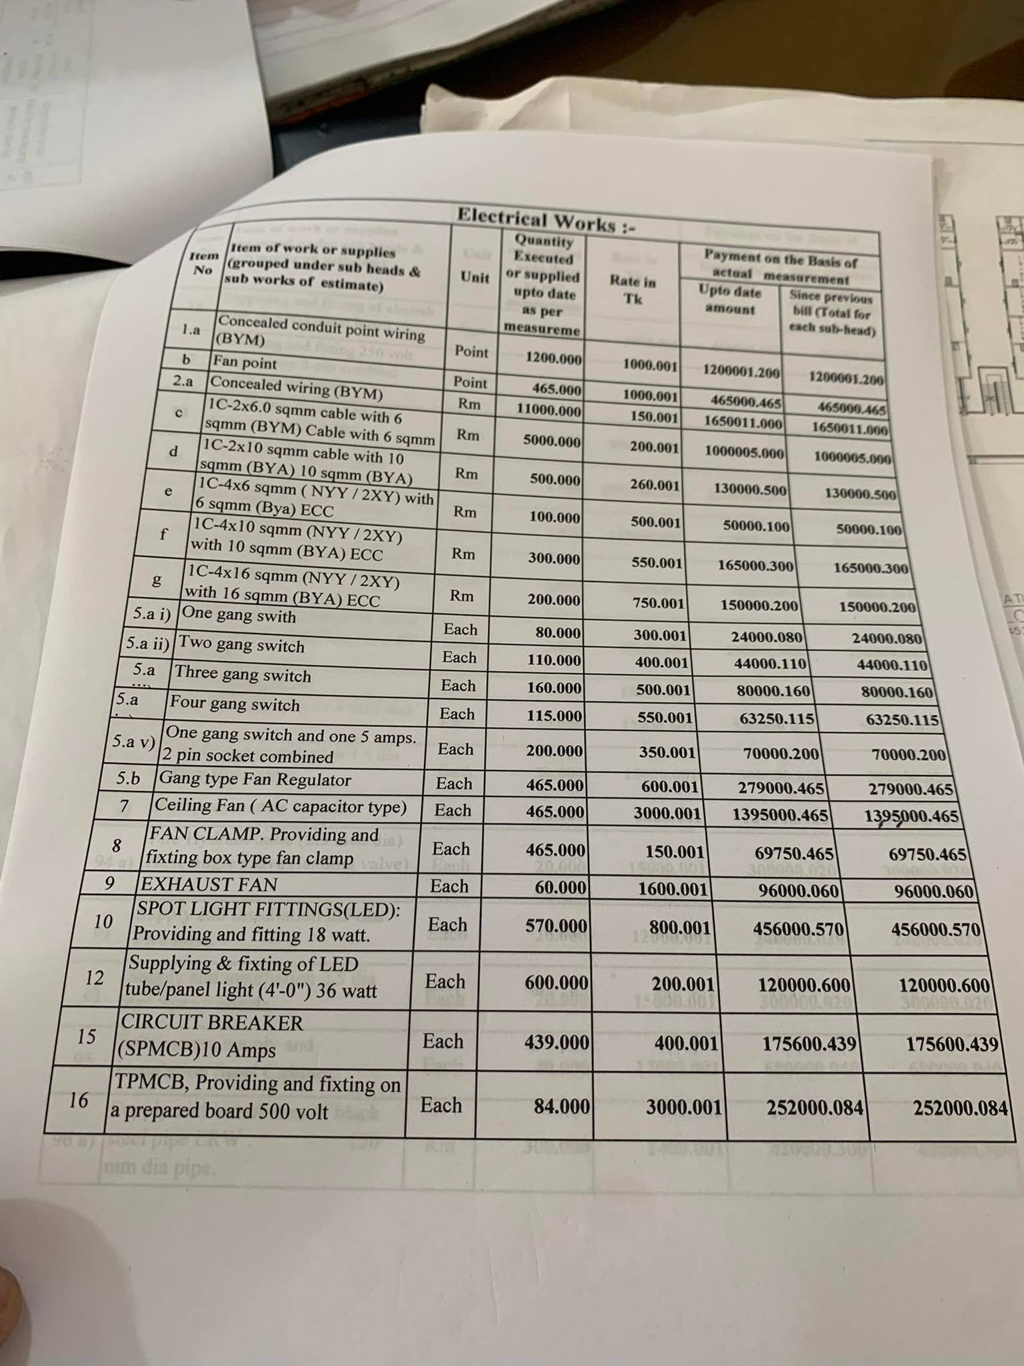

Figure 22 : Bill (Electric)

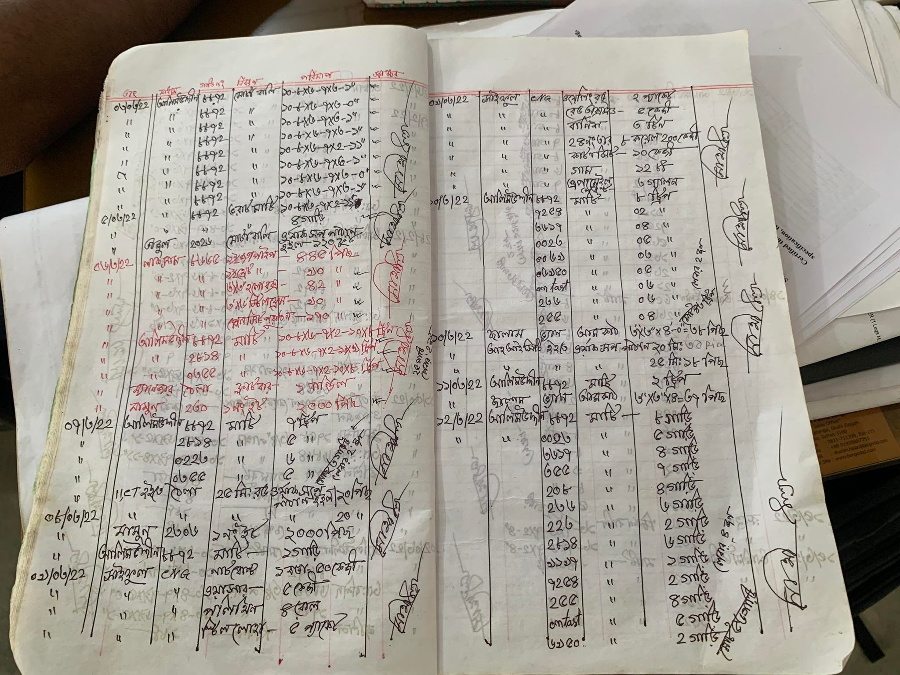

Figure23:Raw Material Receiving Detail

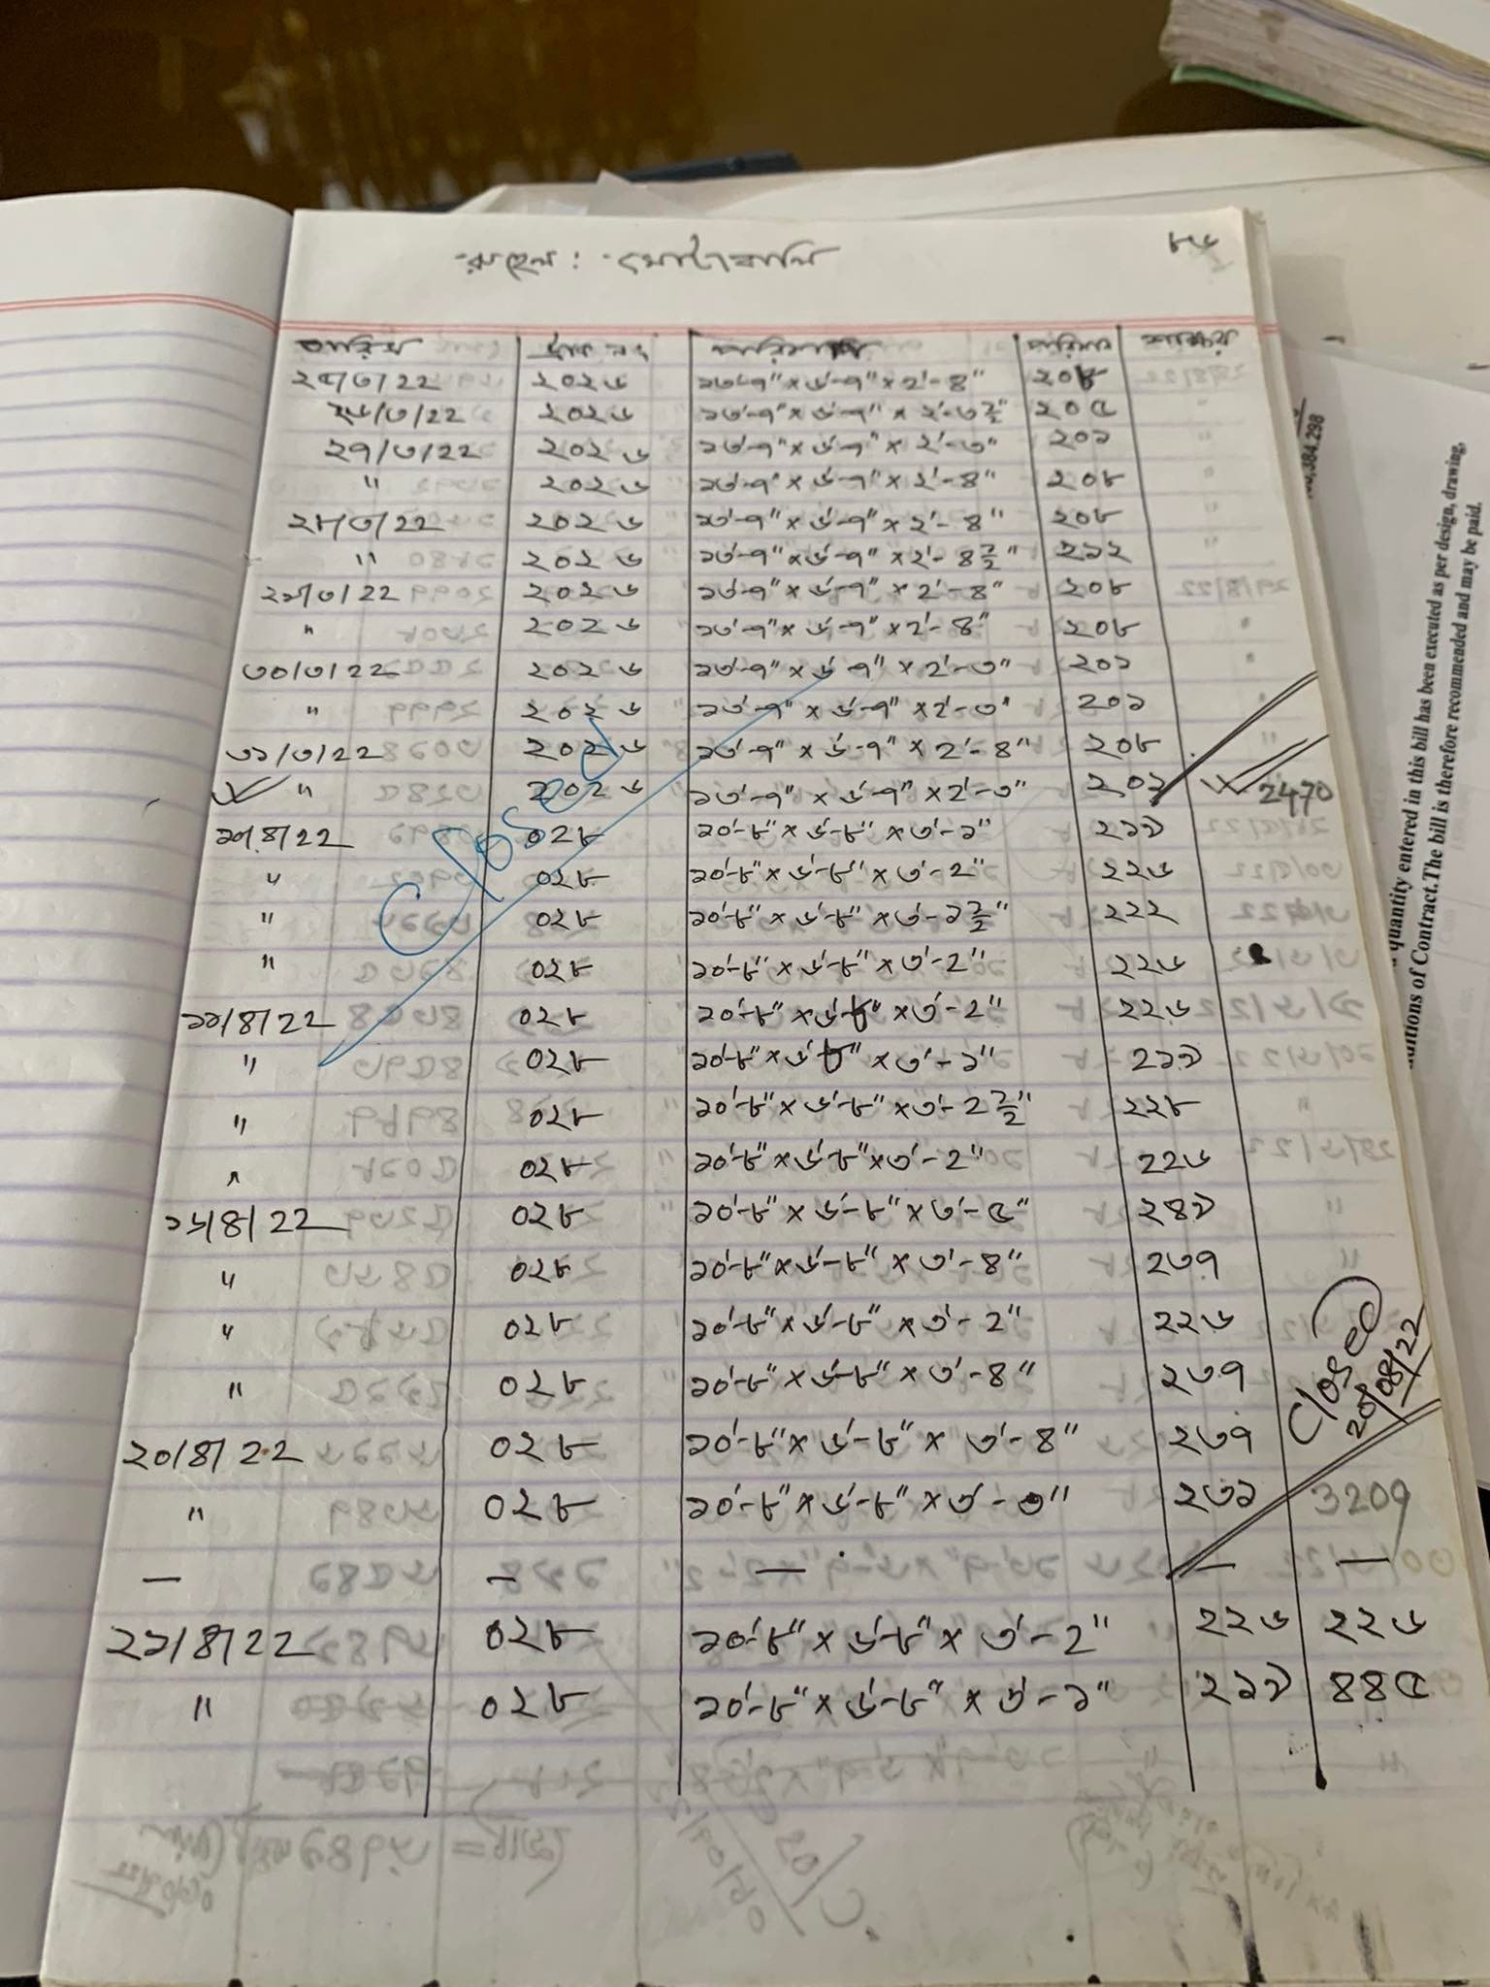

Figure 24:Raw Material Recieving Detail(Sand)

9.Raw Material Inventory and Stock Management

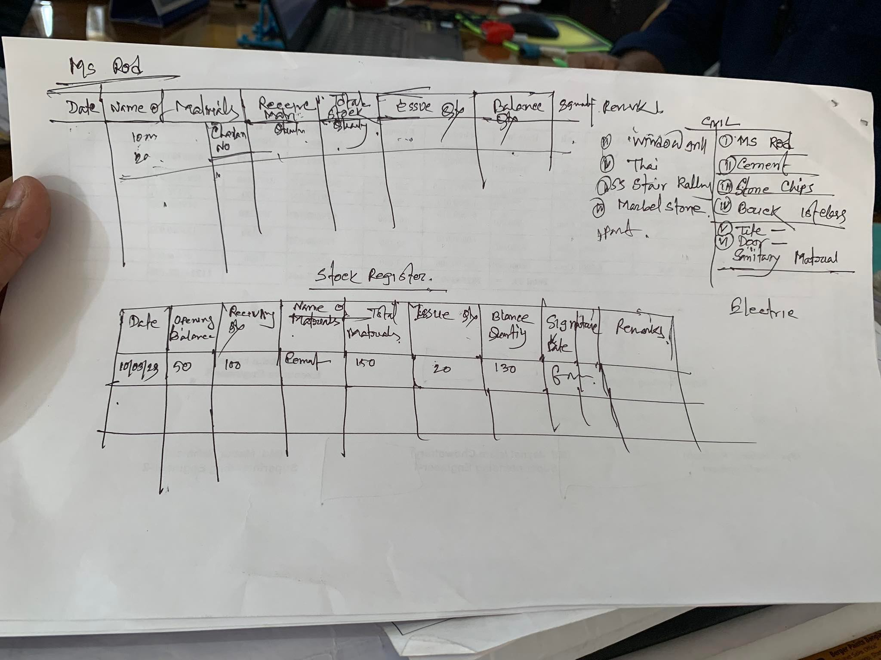

Figure 25 : Raw Maerial Stock (MS ROD)

10.SubContract Management

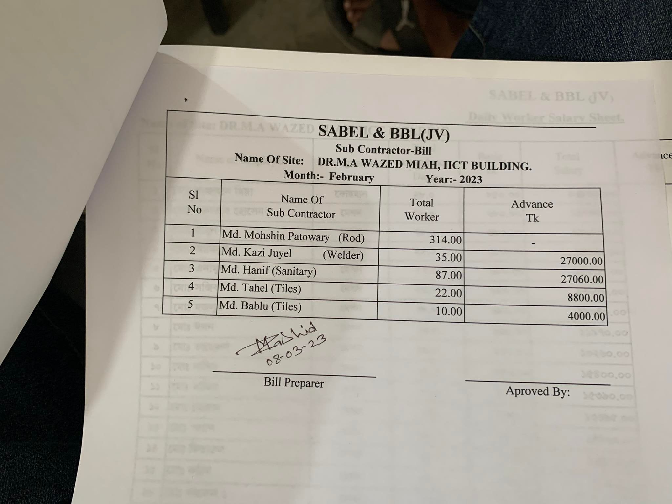

Figure : List Of SubContracts and Details

11.Employee and Staff Attendence Management:

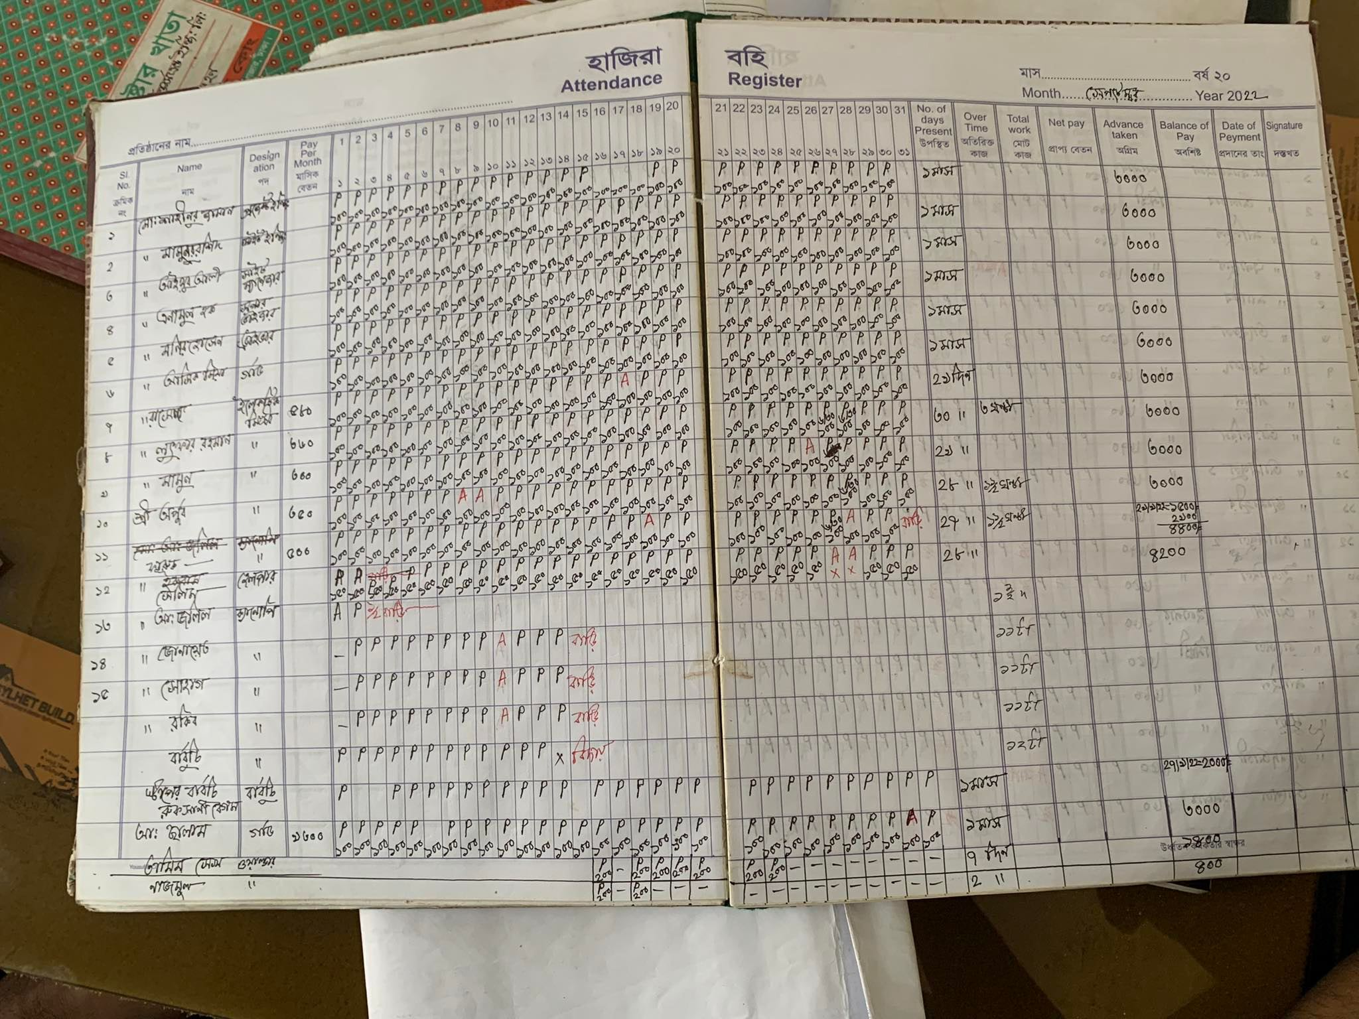

Figure : Attendence sheet of the Workers

12.Other Documents:

1. Site Visitor Data

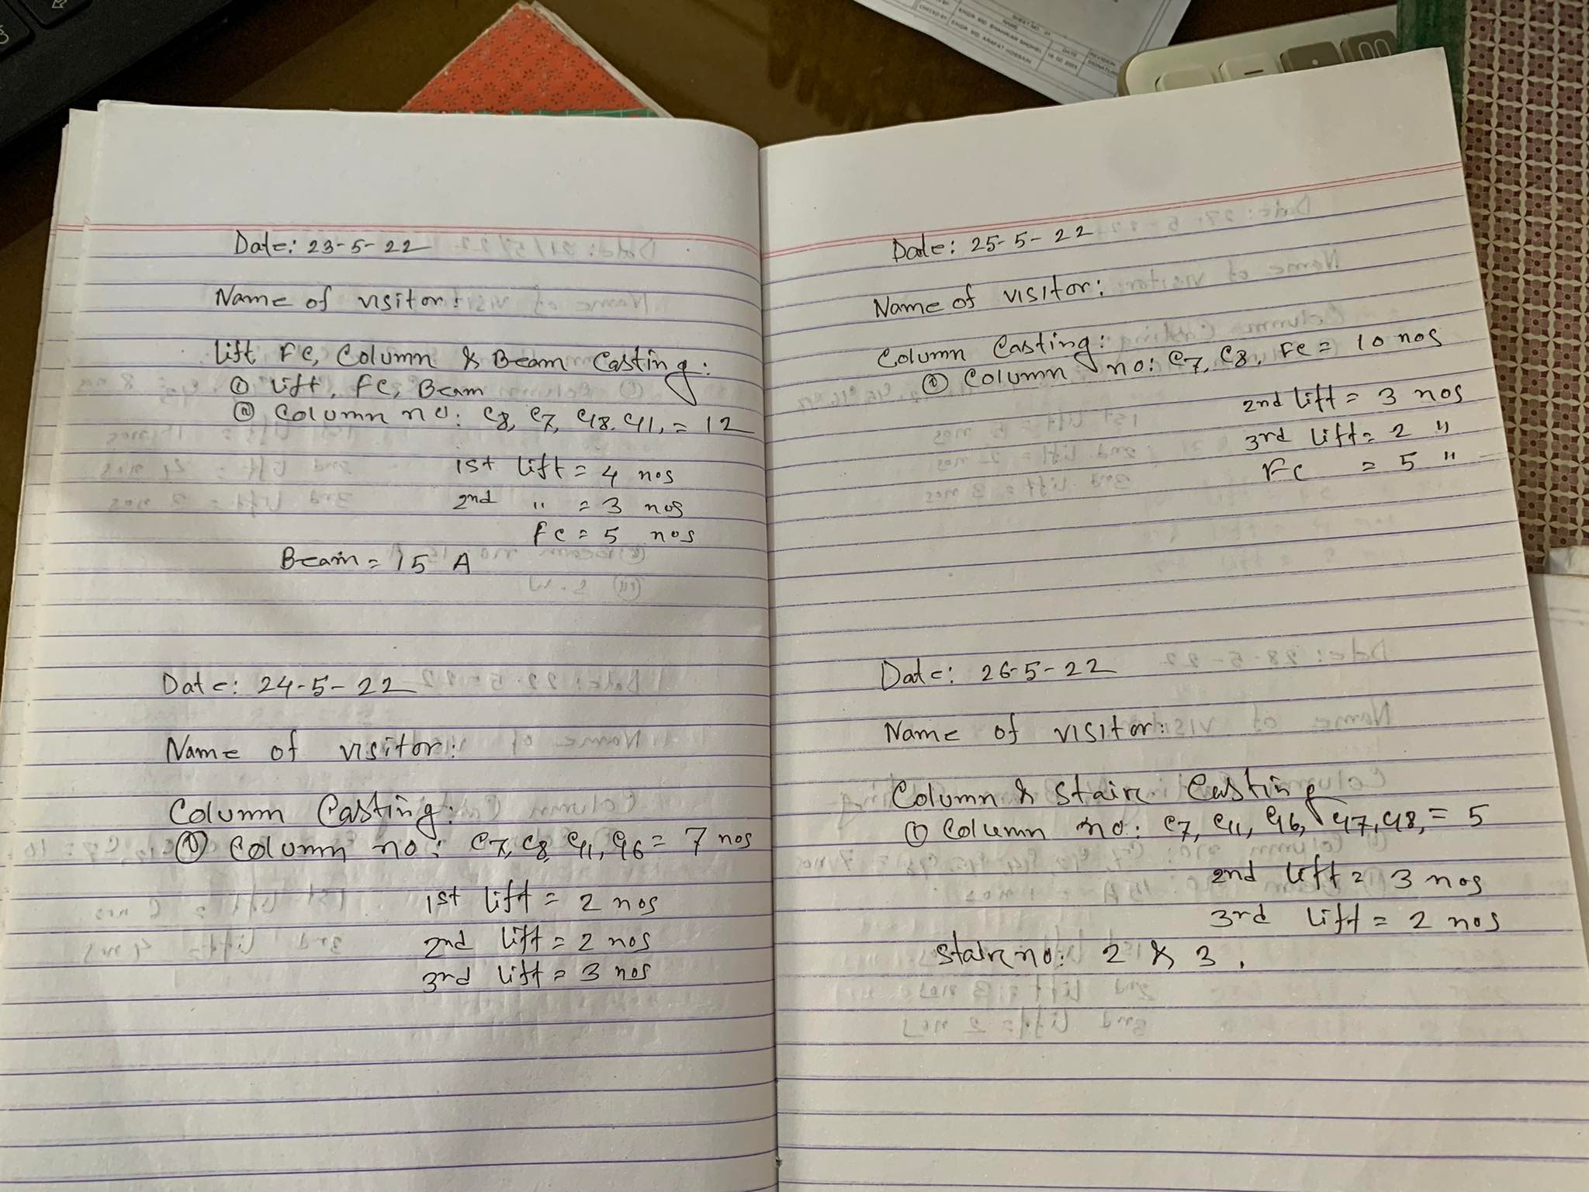

Figure :Site Visitors

End of Data

--------------------------------------------------------00-------------------------------------------------------